**Capstone 3 Project Report:**

**Store Item Demand Forecasting**

Problem statement:

The objective of this project is to predict three months of sales for each store and item. The goal is to analyze any patterns in the sales data like seasonality, whether any relationship exists between different stores or items. Different forecasting methods will be used to forecast the sales and performance will be evaluated using SMAPE.

Context:

Accurate sales prediction is a crucial element for the operational success of major retail players like Walmart, Target, and Costco. It enables these companies to strategically manage inventory by making informed decisions on which products to stock and replenish. A robust forecasting system not only enhances supply chain efficiency but also provides a competitive advantage in the fiercely competitive retail landscape. Given the abundance of choices for each product and the dynamic nature of the market, precise anticipation of customer demand becomes instrumental in outperforming other retailers.

Data:

Data comprises of two csv files ‘train.csv’ and ‘test.csv’. As the names suggest the ‘train.csv’ will be used for training the forecasting model and ‘test.csv’ will be used to test the model performance. The data comprises of 4 columns (features) including ‘date’, ‘store’, ‘item’ and ‘sales’. The training data is big (17 MB) and the testing data is small as expected (1 MB). The ‘data’ column lists the date of the sale. The ‘store’ column lists the store id and ‘item’ lists the item id. The ‘sales’ column lists the number of items sold that that day.

Since we do not have the ‘Sales’ information from the ‘test.csv’ file, we will use last three months from “train.csv” as test data. That way we have a way to validate our prediction and calculate the errors in prediction.

Data Wrangling:

The original dataset was loaded and there were four columns and 913000 rows or instances. The four columns are: ‘date’, ‘store’, ‘item’ and ‘sales’. Next the datatype for the columns were analyzed. The column ‘date’ was of Dtype ‘object’ and rest were of type ‘int’. Next, I looked at the simple statistics for the three columns of integer type.

store item sales

count 913000.00 913000.00 913000.00

mean 5.50 25.50 52.25

std 2.87 14.43 28.80

min 1.00 1.00 0.00

25% 3.00 13.00 30.00

50% 5.50 25.50 47.00

75% 8.00 38.00 70.00

max 10.00 50.00 231.00

Table 1: Basic statistics for the three integer type columns for the entire dataset.

It seems like ‘store’ stores the store_id and ‘item’ stores the ‘item_id’ that were sold on ‘date’. So each row indicates a transaction which stores the information of the store where the sale was made and the item. Next, the number of unique stores and items were examined in the dataset.

Below is a list of unique store ids in the training data and their representation:

1 91300

2 91300

3 91300

4 91300

5 91300

6 91300

7 91300

8 91300

9 91300

10 91300

Below is a list of unique items in the training data and their representation:

1 18260

2 18260

3 18260

4 18260

5 18260

6 18260

7 18260

8 18260

9 18260

10 18260

11 18260

12 18260

13 18260

14 18260

15 18260

16 18260

17 18260

18 18260

19 18260

20 18260

21 18260

22 18260

23 18260

24 18260

25 18260

26 18260

27 18260

28 18260

29 18260

30 18260

31 18260

32 18260

33 18260

34 18260

35 18260

36 18260

37 18260

38 18260

39 18260

40 18260

41 18260

42 18260

43 18260

44 18260

45 18260

46 18260

47 18260

48 18260

49 18260

50 18260

Table 2: Unique store ids and item ids check

There were a total of 10 stores and a total of 50 items were sold in each store. The number of sale instances were same for each store and item combination. The data has a very uniform distribution and is likely synthetic dataset. Next the dataset was checked for any null values and there were none found. Very clean dataset and ready for analysis.

Exploratory Data Analysis:

After data wrangling exploratory data analysis was done. Specifically, the following steps were taken to analyze the data:

* Convert time variable to pandas datetime object
* Generate other columns for date such as day of the week, month, year etc.
* Check total time range: start date, end date, total number of days
* Check for missing days
* Generate summary stats for each store
* Generate summary stats for each item
* Plot histogram of daily sales for each store and all stores combined
* Plot box plots for each day of the week for each store and all stores combined
* Time plot of daily sales for each store
* Time plot of daily sales for each store with a moving average window
* Time plot of weekly sales for each store
* Time plot of monthly sales for each store
* Correlation plot for daily sales from different stores
* Check for any degeneracies in the data

**Date analysis:**

The ‘Date’ column was already a pandas date time object. The start date for the dataset is 2013-01-01 to 2017-12-31. There were a total of 1826 days and there was an entry for sales for each day for each store and item. There were no missing days in the dataset.

Using the ‘Date’ other date related features such as year, month, day of the year and day of the week were extracted and added to the dataframe.

**Summary stats for each store and item:**

The dataset was grouped by store and the sales of all items in the store were summed and summary statistics were generated. The process was repeated for each item and the summary statistics for the sales of each item across all stores were generated. The following table lists the store-wise and item-wise summary statistics.

Summary statistics for sales at each store

store count sum mean median std min max

0 1 91300 4315603 47.268379 44.0 24.006252 1 155

1 2 91300 6120128 67.033165 62.0 33.595810 3 231

2 3 91300 5435144 59.530602 55.0 29.974102 3 196

3 4 91300 5012639 54.902946 51.0 27.733097 4 186

4 5 91300 3631016 39.770164 37.0 20.365757 2 130

5 6 91300 3627670 39.733516 37.0 20.310451 0 134

6 7 91300 3320009 36.363735 34.0 18.684825 1 122

7 8 91300 5856169 64.142048 60.0 32.231751 4 204

8 9 91300 5025976 55.049025 51.0 27.832186 4 195

9 10 91300 5360158 58.709288 54.0 29.554994 3 187

Summary statistics for sales for each item

item count sum mean median std min max

0 1 18260 401384 21.981599 21.0 8.468922 1 59

1 2 18260 1069564 58.574151 56.0 20.093015 9 150

2 3 18260 669087 36.642223 35.0 13.179441 7 104

3 4 18260 401907 22.010241 21.0 8.403898 0 66

4 5 18260 335230 18.358708 18.0 7.265167 1 50

5 6 18260 1068281 58.503888 56.0 20.174898 11 148

6 7 18260 1068777 58.531051 56.0 20.146002 11 141

7 8 18260 1405108 76.950055 74.0 26.130697 15 181

8 9 18260 938379 51.389869 49.5 17.790158 6 134

9 10 18260 1337133 73.227437 70.0 24.823725 14 175

10 11 18260 1271925 69.656353 67.0 23.744732 11 170

11 12 18260 1271534 69.634940 67.0 23.738663 12 170

12 13 18260 1539621 84.316594 81.0 28.311031 20 210

13 14 18260 1071531 58.681873 56.0 20.079860 12 152

14 15 18260 1607442 88.030778 85.0 29.522852 17 231

15 16 18260 468480 25.656079 25.0 9.603270 2 70

16 17 18260 602486 32.994852 32.0 11.967610 4 83

17 18 18260 1538876 84.275794 81.0 28.430621 18 208

18 19 18260 736892 40.355531 39.0 14.332645 5 99

19 20 18260 867641 47.515936 46.0 16.490487 9 127

20 21 18260 736190 40.317087 39.0 14.338006 7 109

21 22 18260 1469971 80.502245 78.0 27.118163 14 214

22 23 18260 534979 29.297864 28.0 10.819549 3 81

23 24 18260 1205975 66.044633 64.0 22.531555 14 156

24 25 18260 1473334 80.686418 78.0 27.238817 18 193

25 26 18260 869981 47.644085 46.0 16.723912 8 119

26 27 18260 402628 22.049726 21.0 8.461641 1 59

27 28 18260 1604713 87.881325 85.0 29.501781 16 206

28 29 18260 1271240 69.618839 67.0 23.635631 15 173

29 30 18260 736554 40.337021 39.0 14.363331 5 115

30 31 18260 1070845 58.644304 57.0 20.104705 10 159

31 32 18260 803107 43.981763 42.0 15.574556 5 119

32 33 18260 1270183 69.560953 67.0 23.718343 15 169

33 34 18260 469935 25.735761 25.0 9.617910 2 79

34 35 18260 1201541 65.801807 63.0 22.461990 12 168

35 36 18260 1406548 77.028916 74.0 26.067440 16 188

36 37 18260 534258 29.258379 28.0 10.771547 3 74

37 38 18260 1470330 80.521906 77.0 27.141799 15 188

38 39 18260 801311 43.883406 42.0 15.511550 7 112

39 40 18260 534094 29.249398 28.0 10.822959 3 74

40 41 18260 401759 22.002136 21.0 8.402470 2 60

41 42 18260 669925 36.688116 35.0 13.215112 5 96

42 43 18260 936635 51.294359 49.0 17.801008 9 126

43 44 18260 536811 29.398193 28.0 10.797738 3 78

44 45 18260 1471467 80.584173 78.0 27.318402 18 205

45 46 18260 1070764 58.639869 56.0 20.220879 11 150

46 47 18260 401781 22.003341 21.0 8.420102 2 61

47 48 18260 937703 51.352848 49.0 17.881917 8 130

48 49 18260 535663 29.335323 28.0 10.874788 3 77

49 50 18260 1203009 65.882202 63.0 22.416031 12 164

Table 3: Store-wise and item-wise summary statistics

Next the total sales for each store and each item were computed and were plotted. Below, is a plot that shows the total sales.

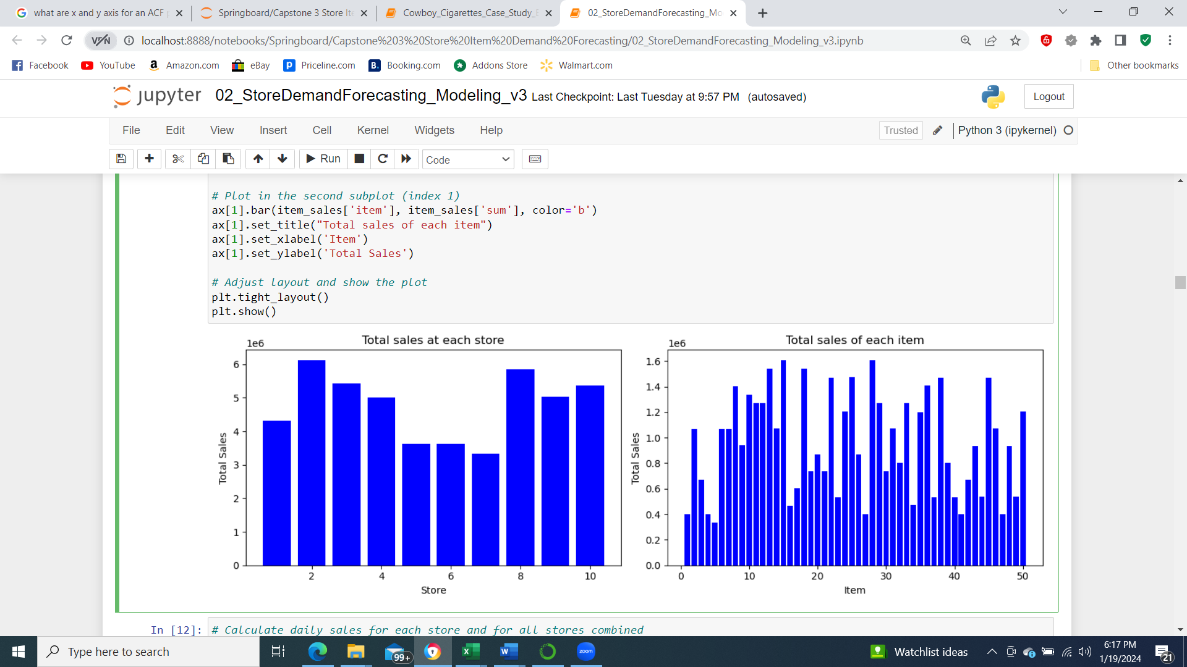

Figure 1: Store-wise and item-wise summary statistics

**Daily sales analysis:**

Daily sales data was generated by grouping the data by date. Total sales for each store individually and all store combined were generated. Histograms were plotted to understand the distribution of the daily sales data. From the Histograms shown in Figure 2 we can see that the distributions were mostly normal and were also fairly similar to each other. It would have been interesting if the distributions for some of the stores were different from others. It seems like we could choose any one store for our analysis.

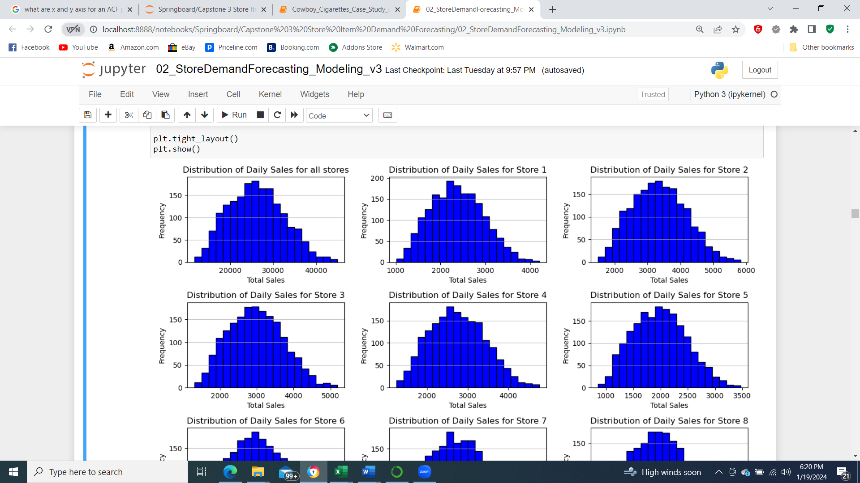

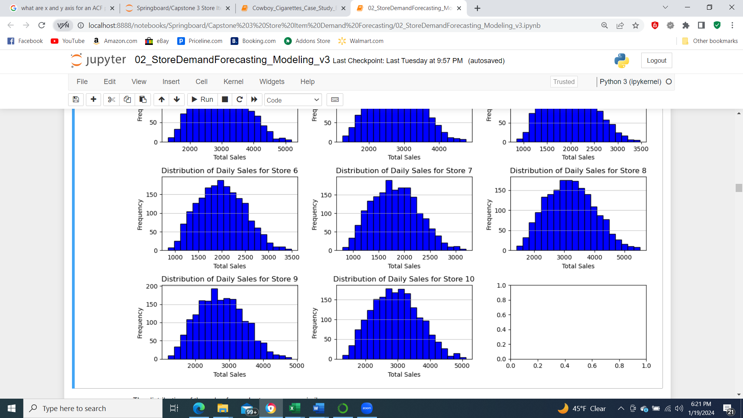

Figure 2: Histograms of daily sales data for each store and all stores combined.

Next, we generated time series plots for the sales data for all items for each store and all stores combined. Figure 3 shows the time series plots. From a visual inspection the time series plots are very similar. There is a gradual positive slope which indicates the sales have an increasing trend yearly. For a particular year the sales are start low and are highest around July and then again are lower. The trends are overall quite consistent across various stores. There could be other potential trends and they will be analyzed when we decompose the time-series plot.

Moving average of a time series, filters the high frequency variations in the data and shows the trends better. Figure 4 shows moving average of Store 1 sales data with different window lengths: 7days, 14 days, 30 days.

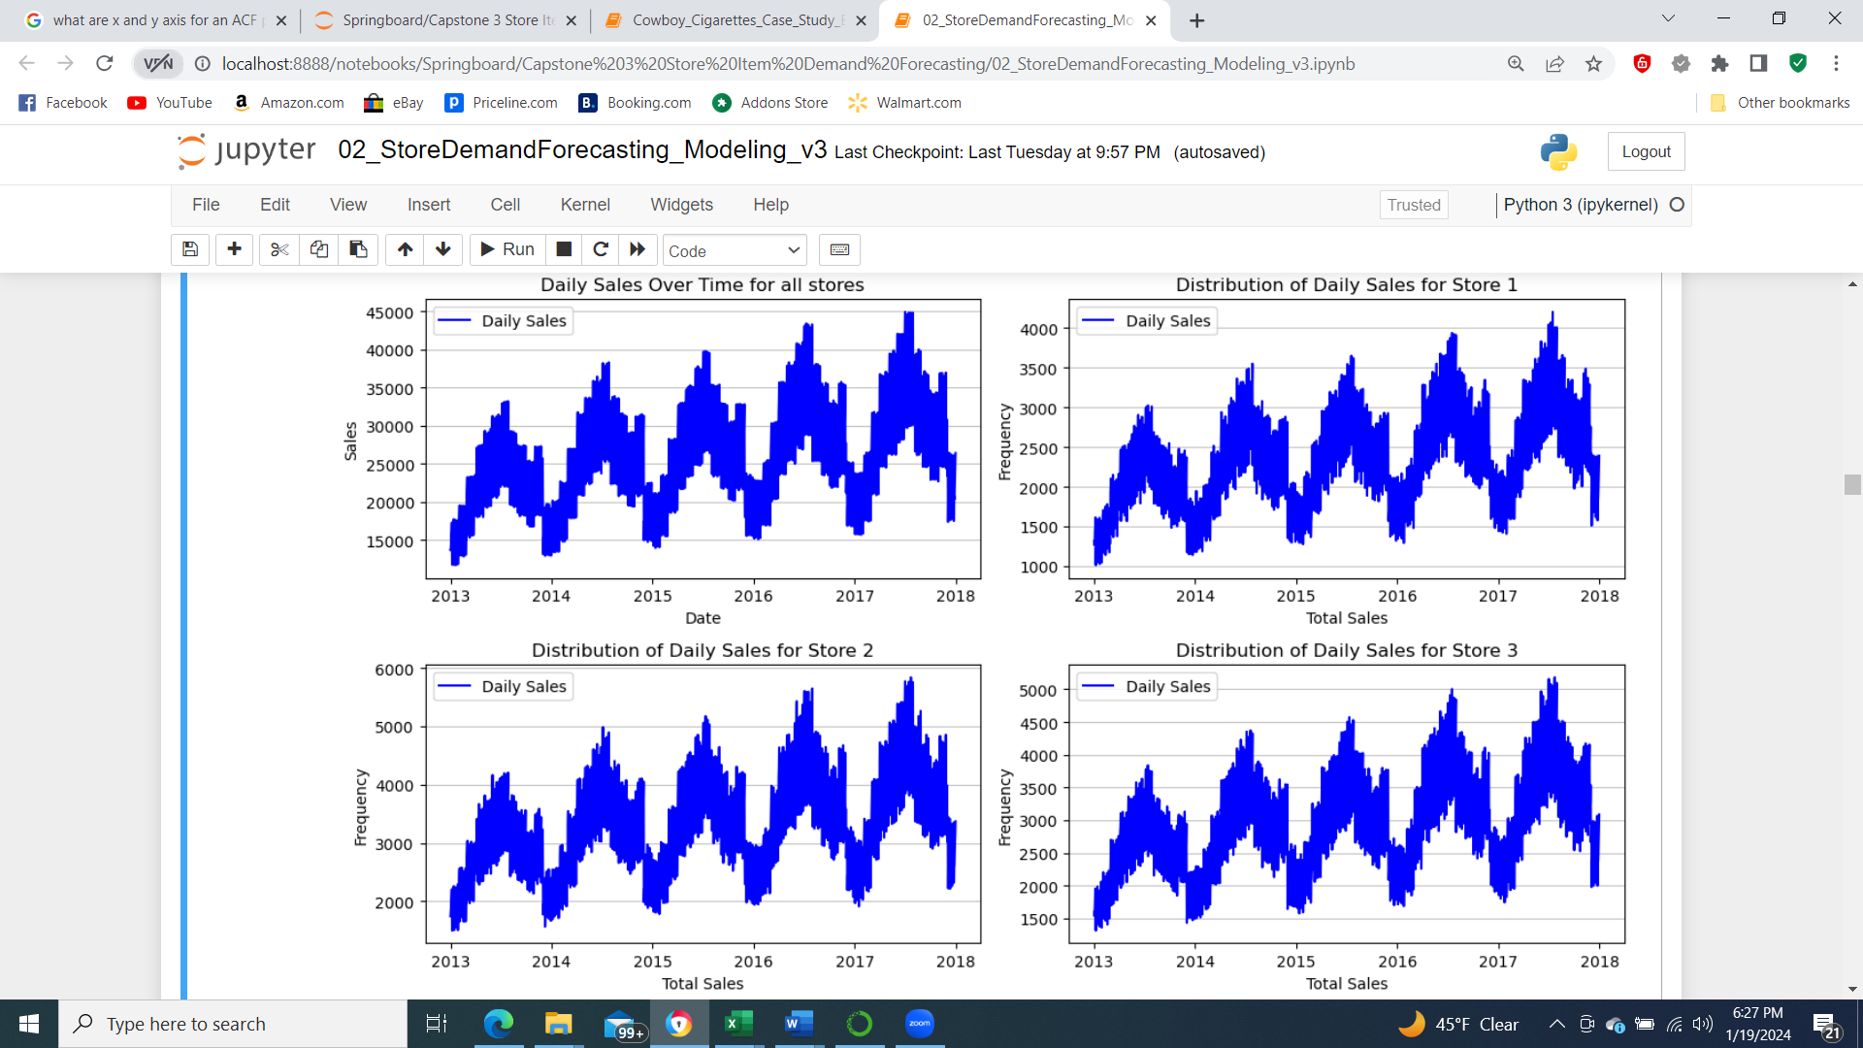

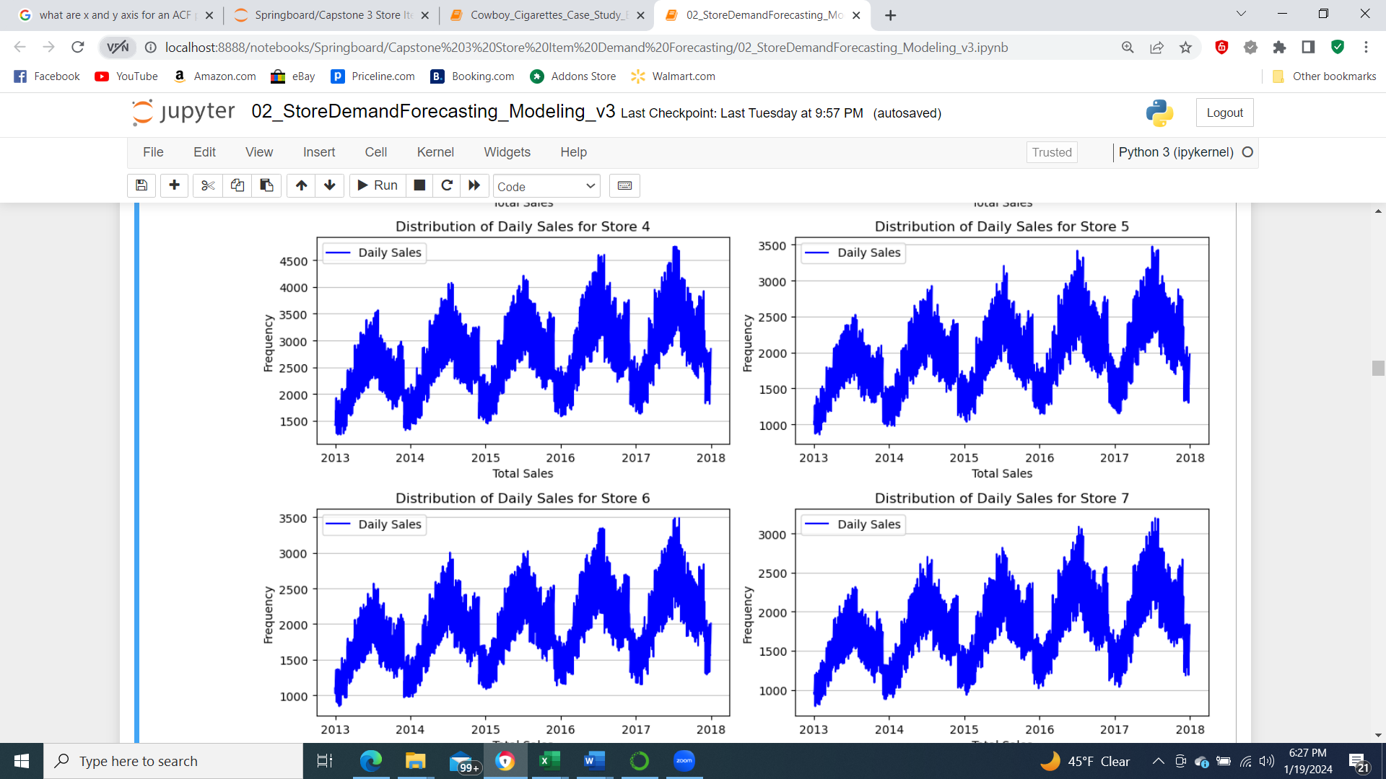

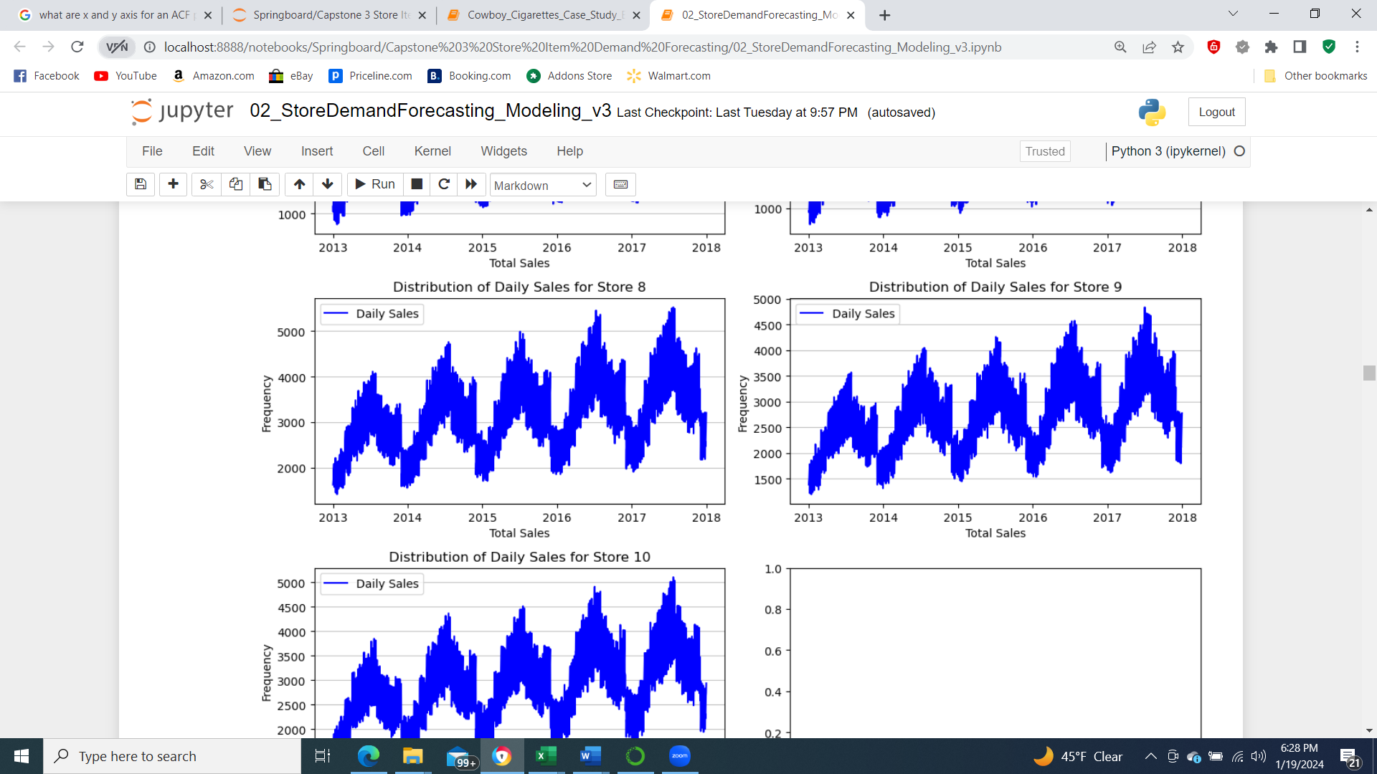

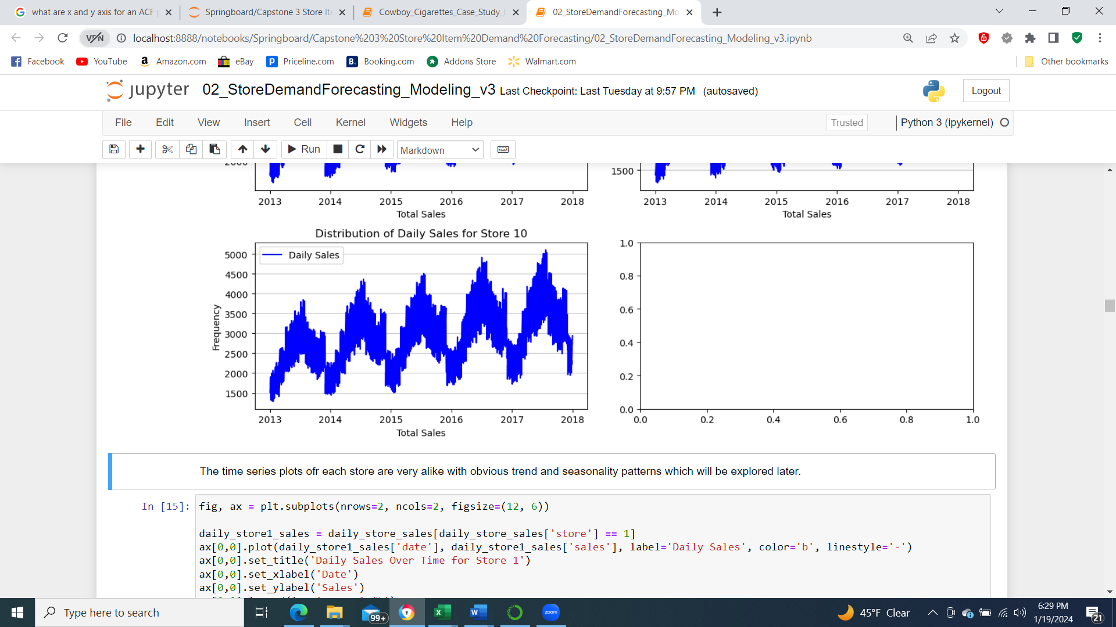

Figure 3: Time series plots of the daily sales data for each store and all stores combined.

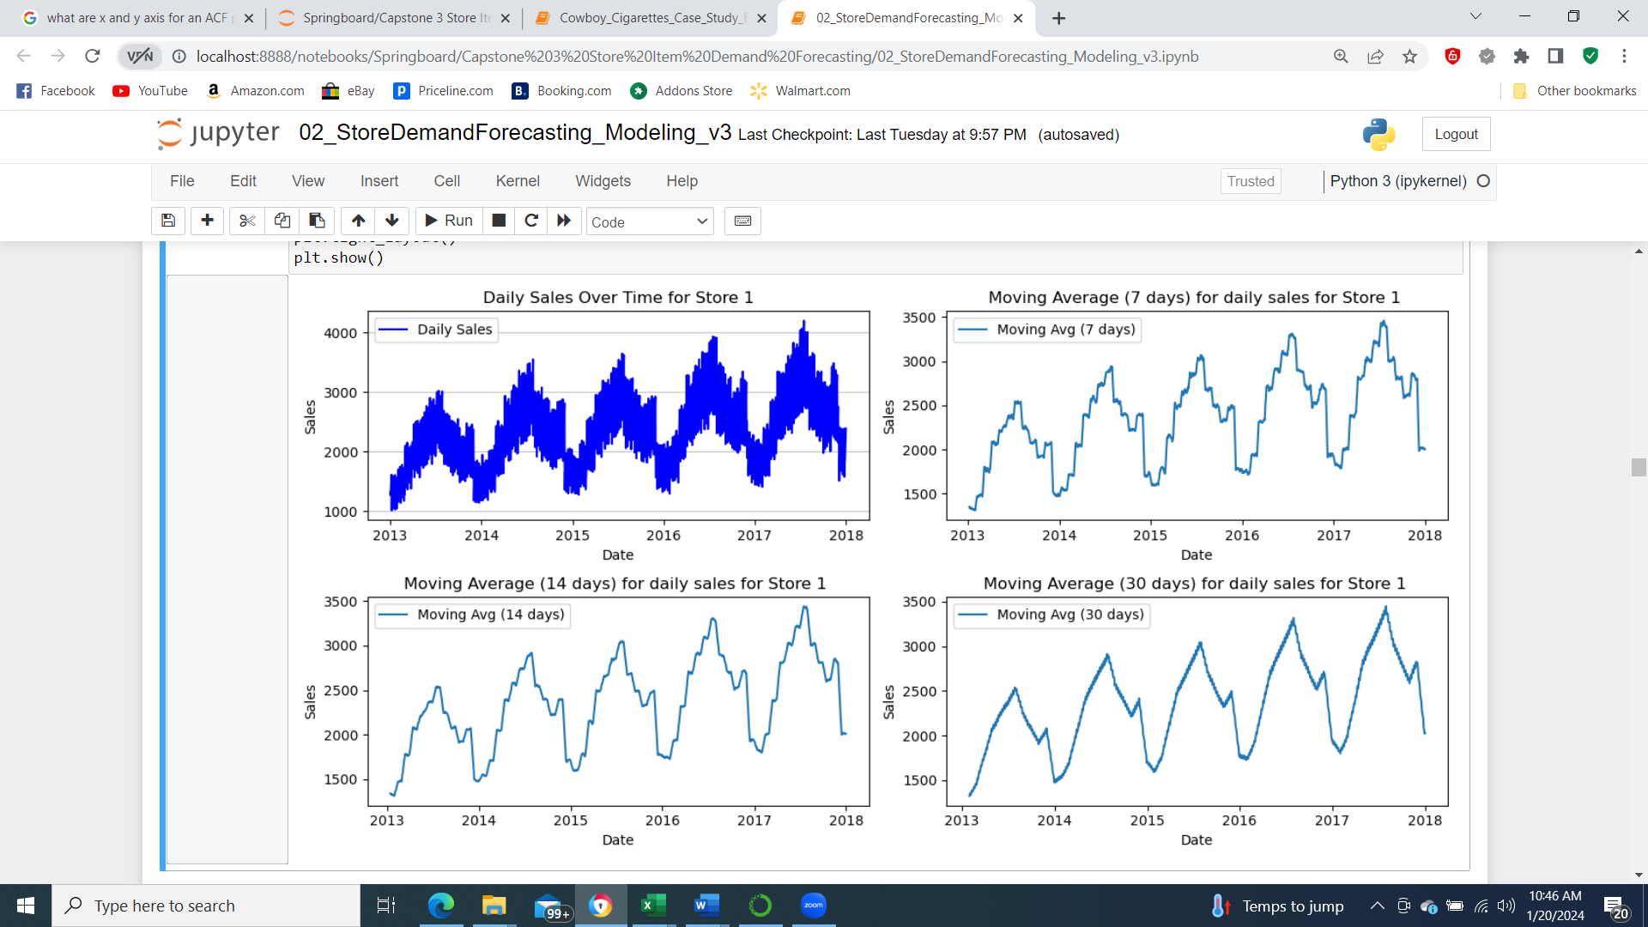

Figure 4: Moving average plots of daily sales data for Store 1.

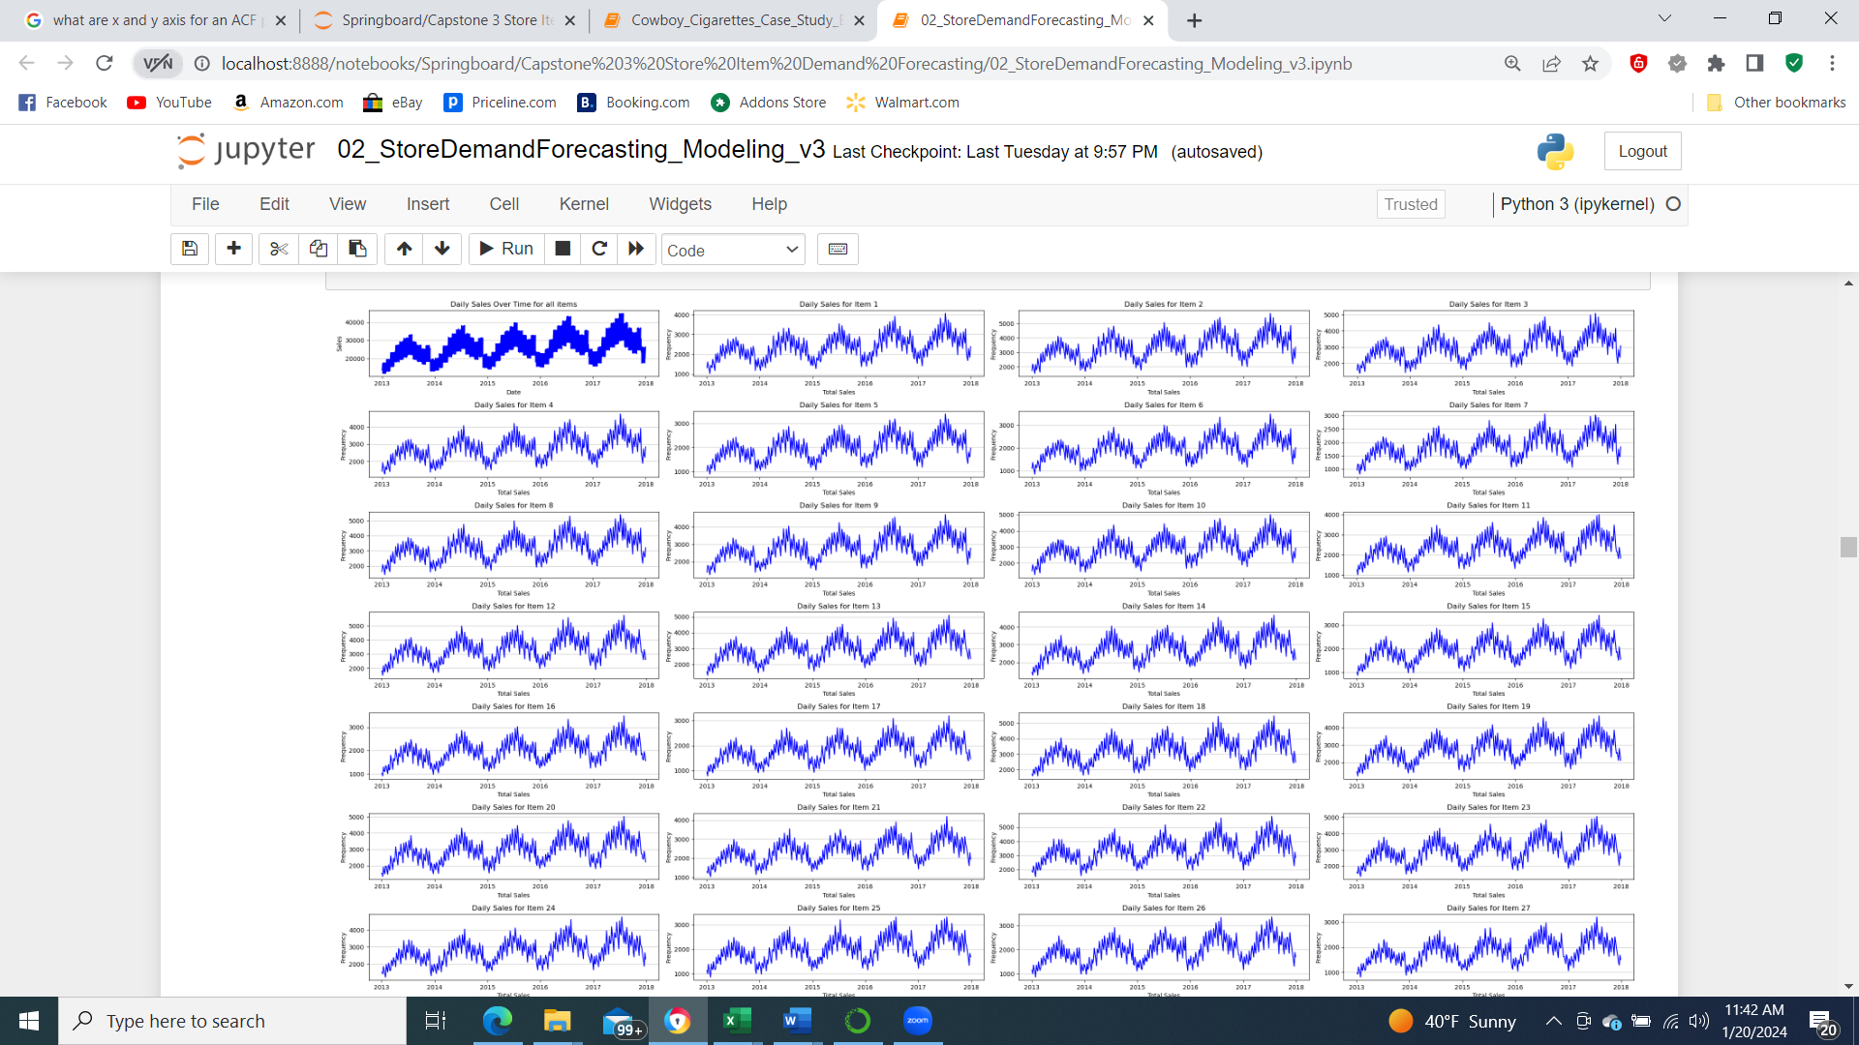

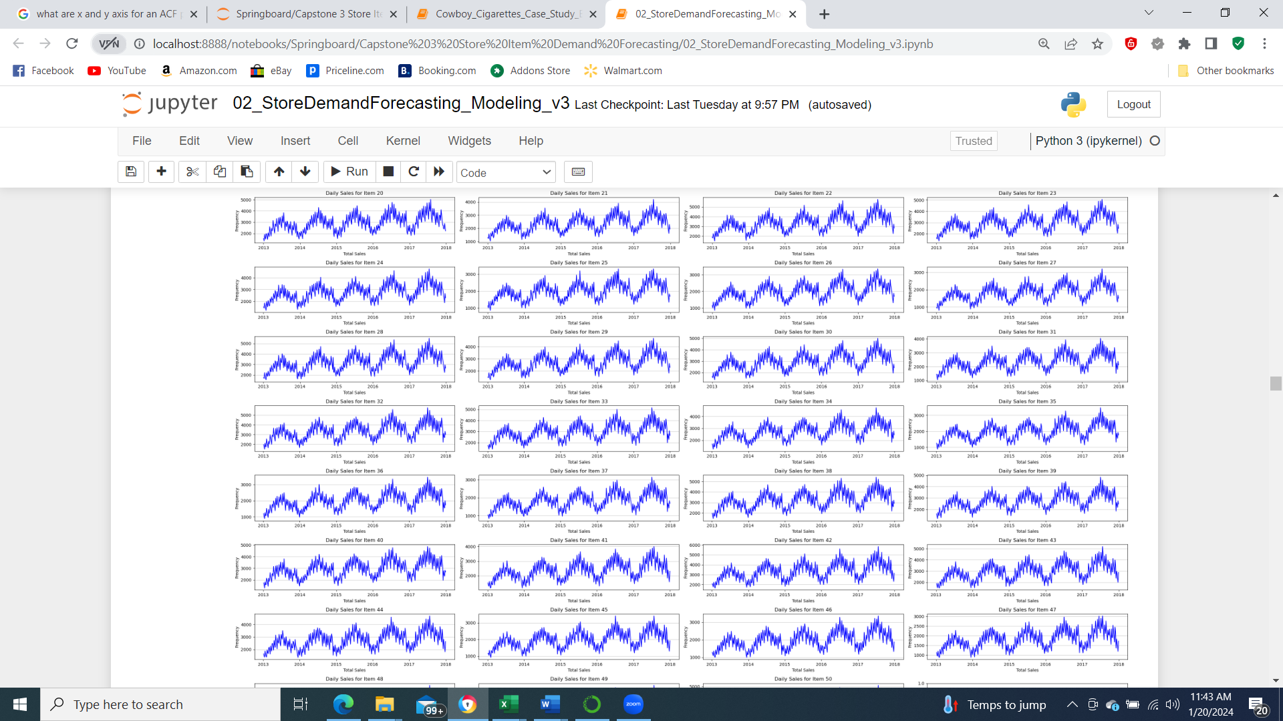

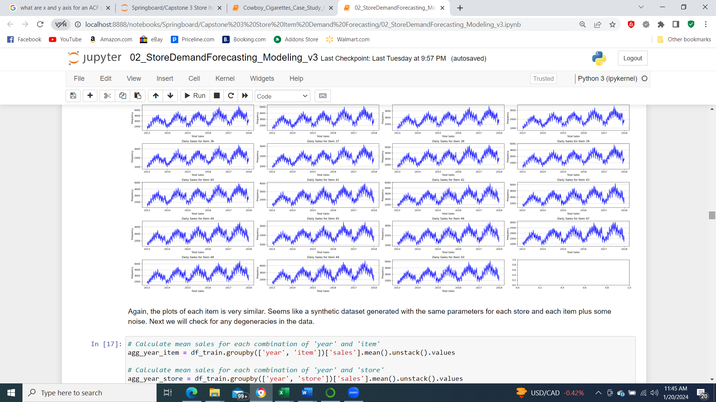

Figure 5: Moving average plots of daily sales data for each item.

Figure 5 shows the time series plot of sales data for each item (across all the stores). The objective is to see any patterns in the data for different items. As we can see that the sales data is quite consistent for all the items across all the stores. As we assumed earlier there is more evidence that the data is a synthetic dataset generated with the same parameters for each store and each item plus some noise. Next, we will check for any degeneracies in the data.

**Checking of degeneracies:**

In order to understand the degeneracies or inter-dependencies in the data I computed mean relative sales for each item over the years. The same calculation is repeated for relative sales of each store over the years. This shows the yearly sales pattern for all the items and stores and as expected they follow a similar trend.

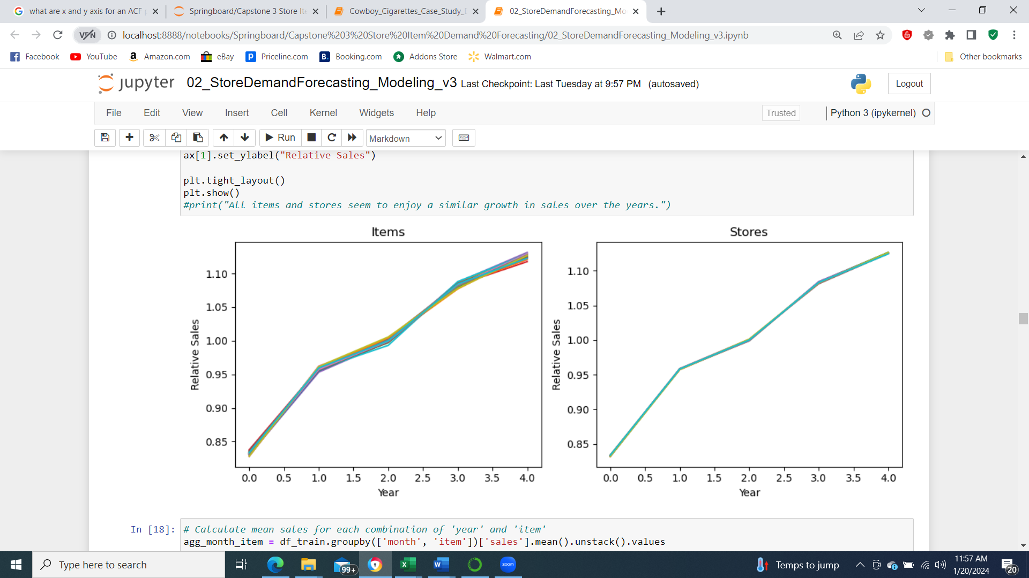

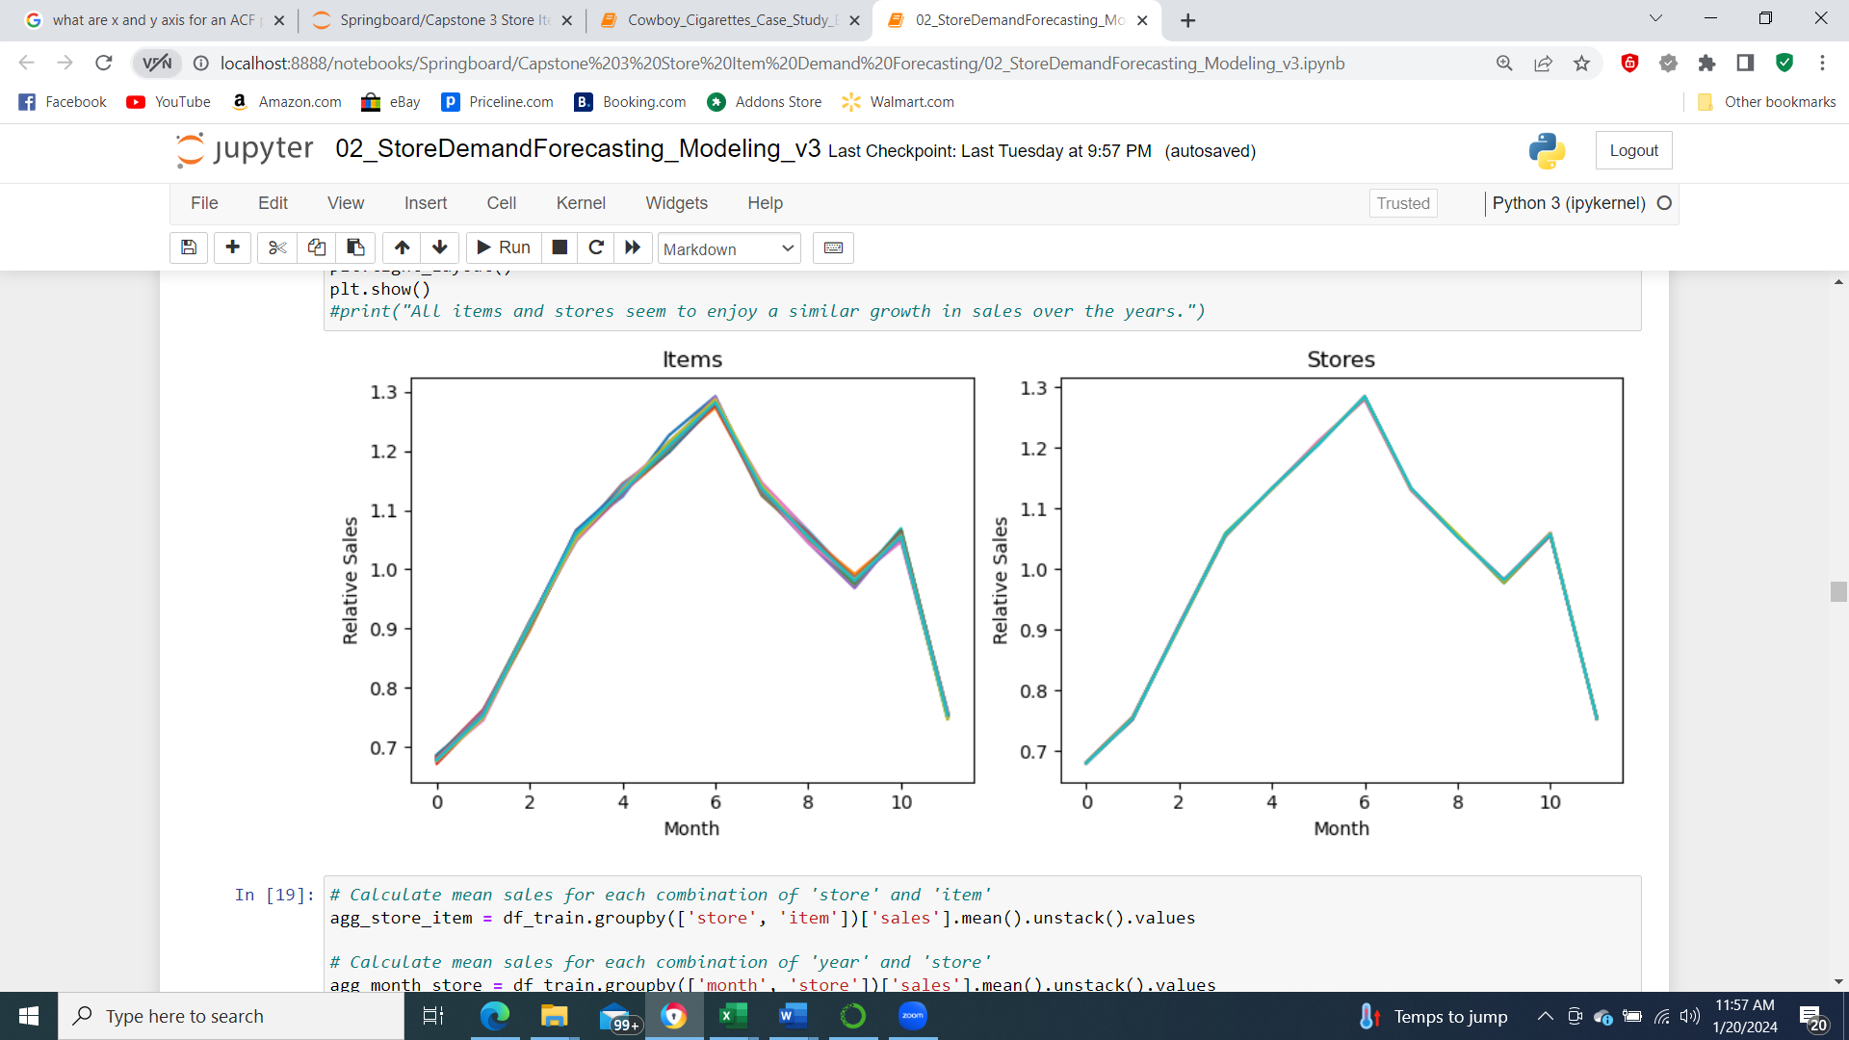

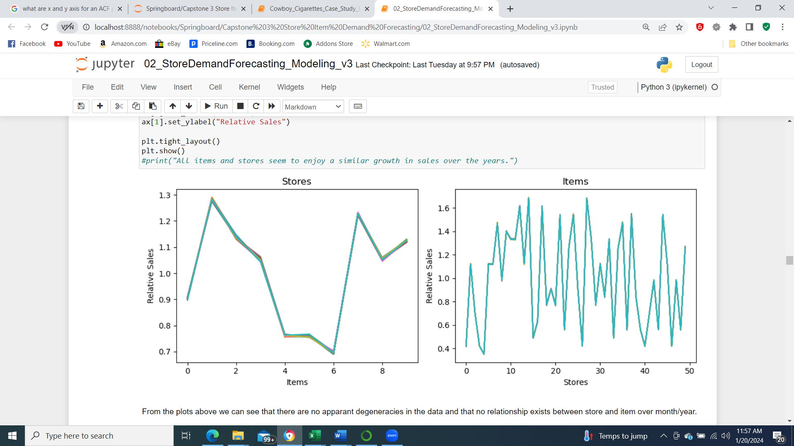

Figure 6: Relative sales trend for items and stores over time.

Figure 6 shows the plots of the relative sales over years and also over months. We observe a very similar trend for all items and stores. The relative sales for items for each store were also checked and again no apparent degeneracies were found in the data.

**Seasonal decomposition:**

The time series sales plot is decomposed into trend, seasonality and residual using an additive assumption and multiplicative assumption. The decomposition plots are shown in Figure 7 and Figure 8. From the decomposition plots we can see that the additive model gives a better estimate of trend and seasonality because the residuals are more normally distributed and random.

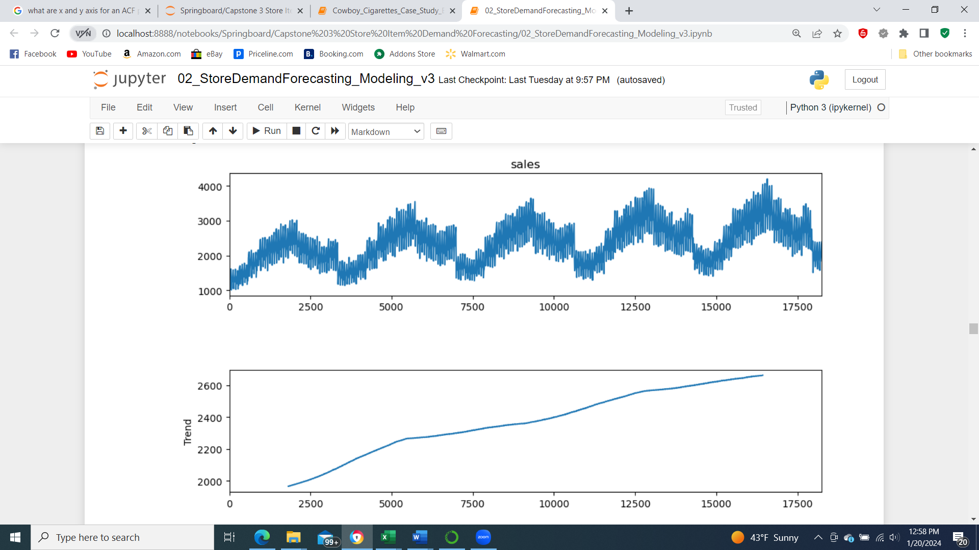

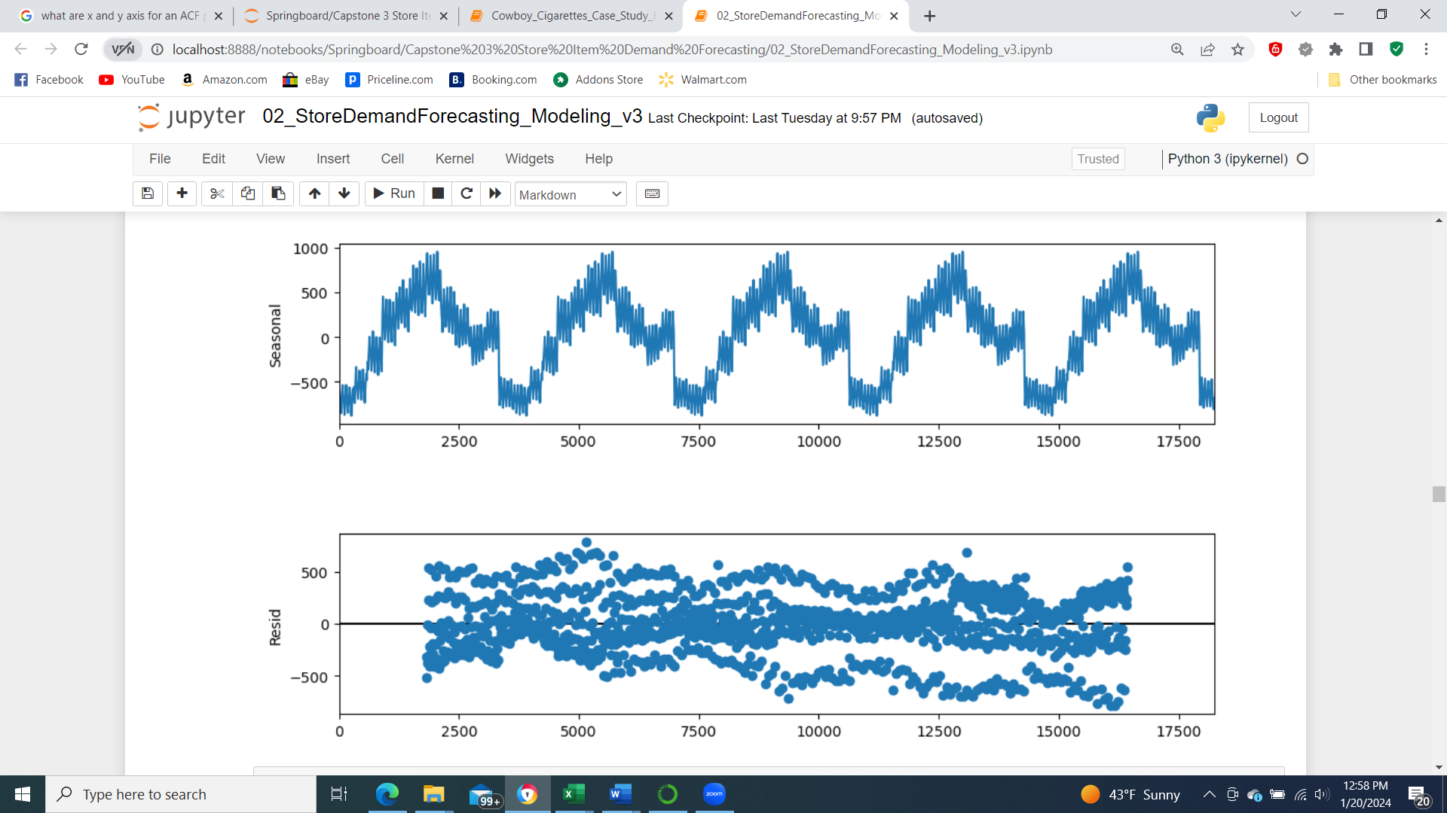

Figure 7: Seasonal decomposition plot assuming an additive model.

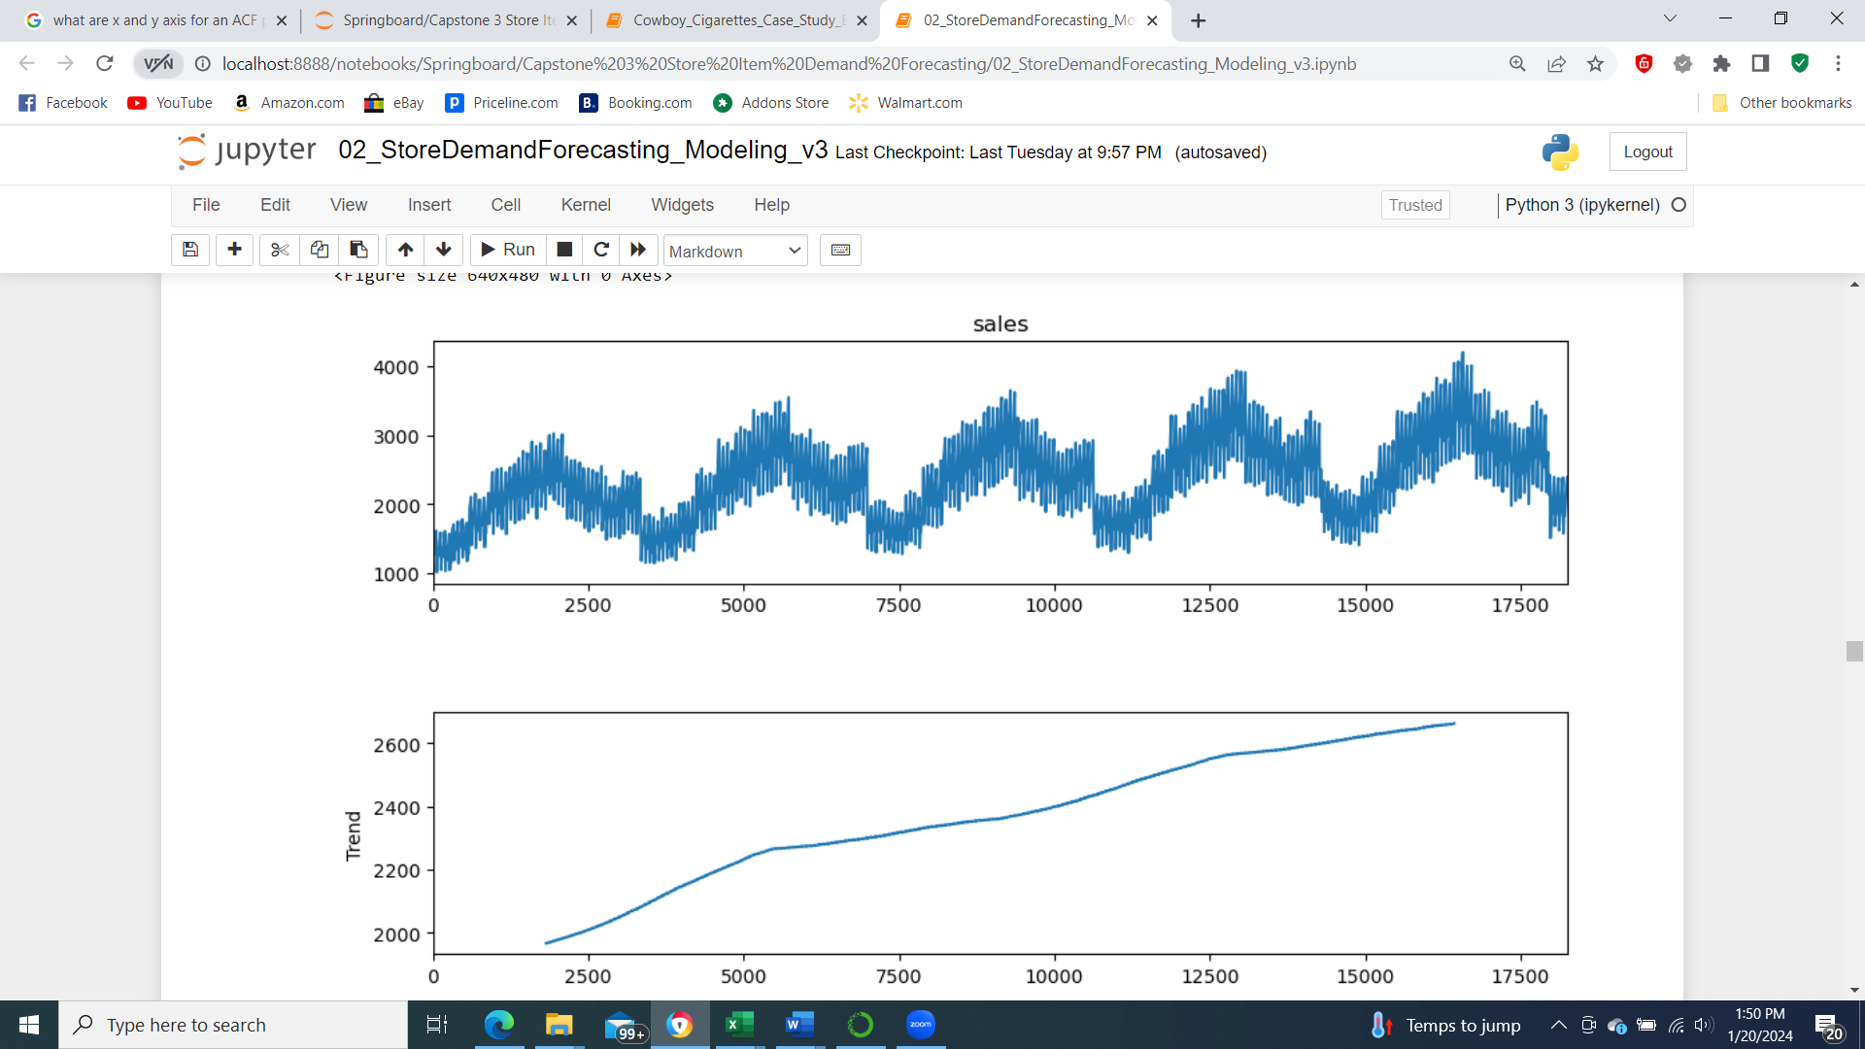

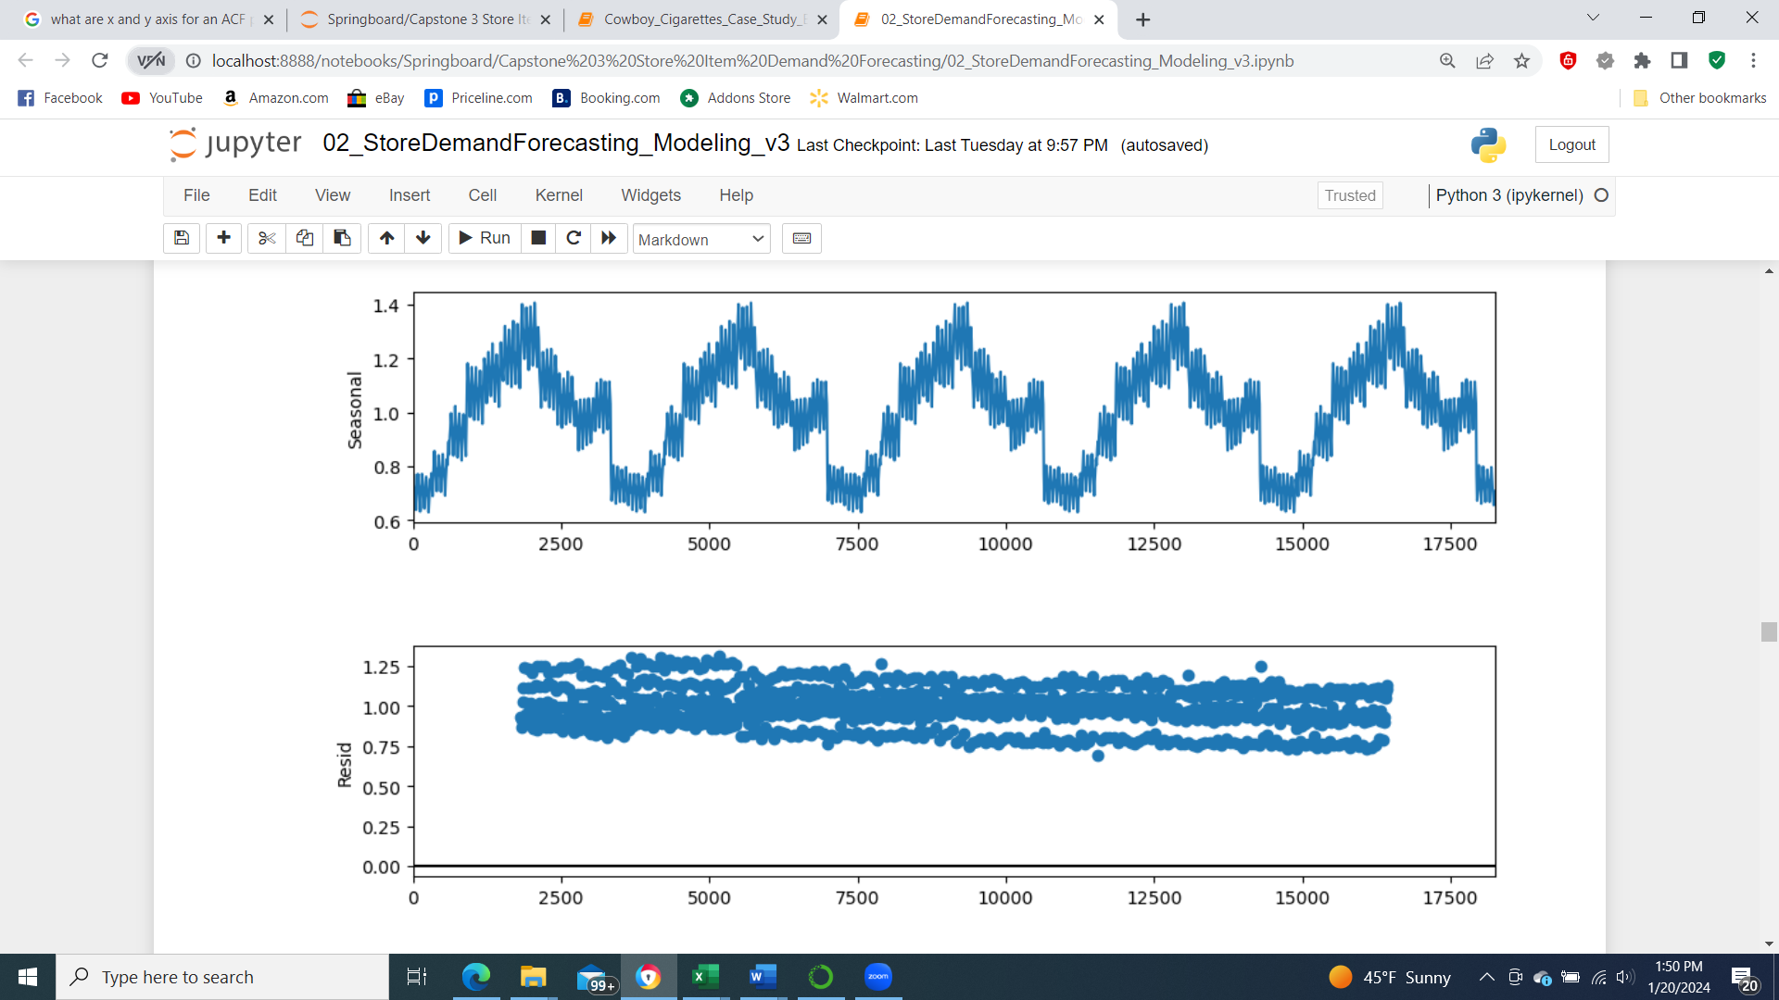

Figure 8: Seasonal decomposition plot assuming a multiplicative model.

Data Preprocessing and Modeling:

After EDA, data preprocessing and modeling were conducted which includes the following steps:

* Generate one dataset for time series prediction
  + Timeseries1 = Store 1 item 1
* Divide the data into training data and test data based on date
* For ARIMA model, estimate parameters p,d,q
  + p is the order of the autoregressive component (AR)
  + q is the order of the moving average component (MA)
  + d is the order of the differencing required to make the time-series stationary
* Estimate p and q from the ACF and PACF plots
* Test for stationarity using Dickey-Fuller test
* If the data is not stationary then test again for first difference
* Continue taking nth difference until the data is stationary
* Model using ARIMA (p,d,q)
* Define an error function to calculate error in prediction
* Derive best parameters of p,d,q by cross-validation
* Test SARIMA model for seasonality effects
* Test SARIMA using exogenous parameters

**Generate training and test data:**

From EDA it was quite apparent that if we could predict for one store and one item we could use a very similar model or procedure to predict other store-item combinations. To start with we generated daily sales data for store 1 and item 1. The data was split by time (2017-10-01). Last three months of data will be used for test and rest of the data will be used to train the models.

**Test for stationarity and estimate d:**

Dickey-Fuller test was performed on the time series data to test for stationarity.

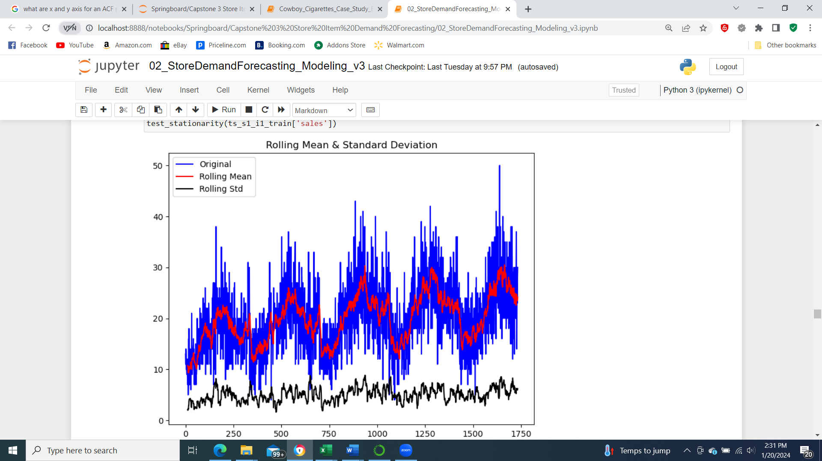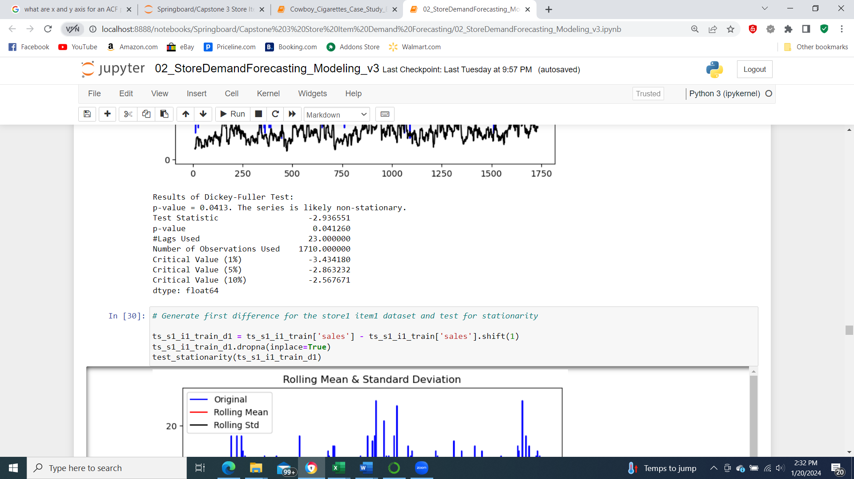

Figure 9: Test for stationarity for the time series data.

Additionally, the time series plot was overlaid with its rolling mean and rolling standard deviation using a window size of 12 samples. From the results of the Dickey-Fuller test we can see that the p-value is not less than 0.05, hence the we cannot reject the null hypothesis that the data is not stationary.

Next, I generated the first difference time series and repeated the stationarity test. Results are shown in Figure 10.

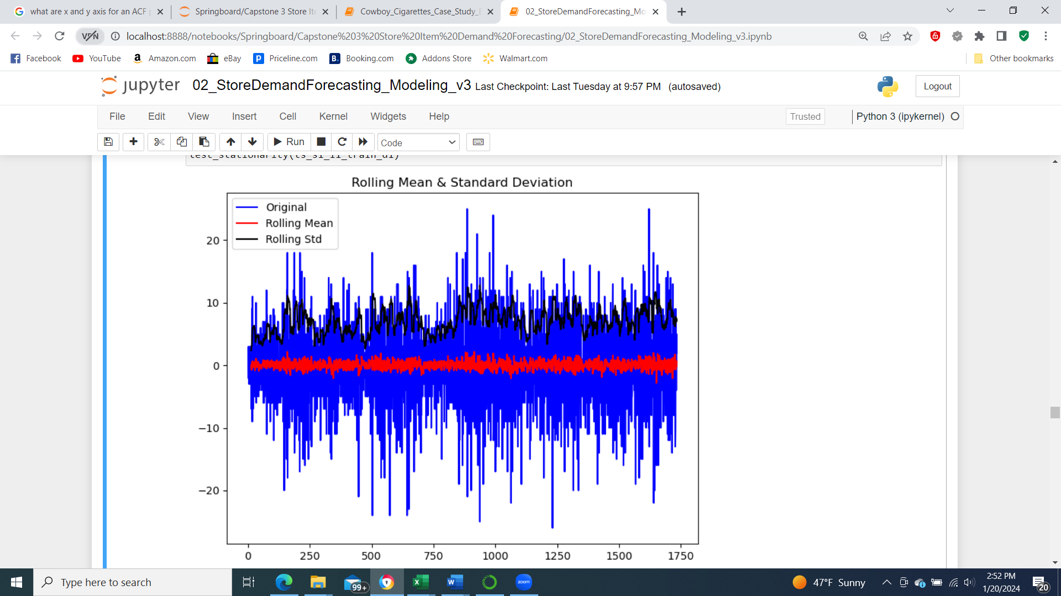 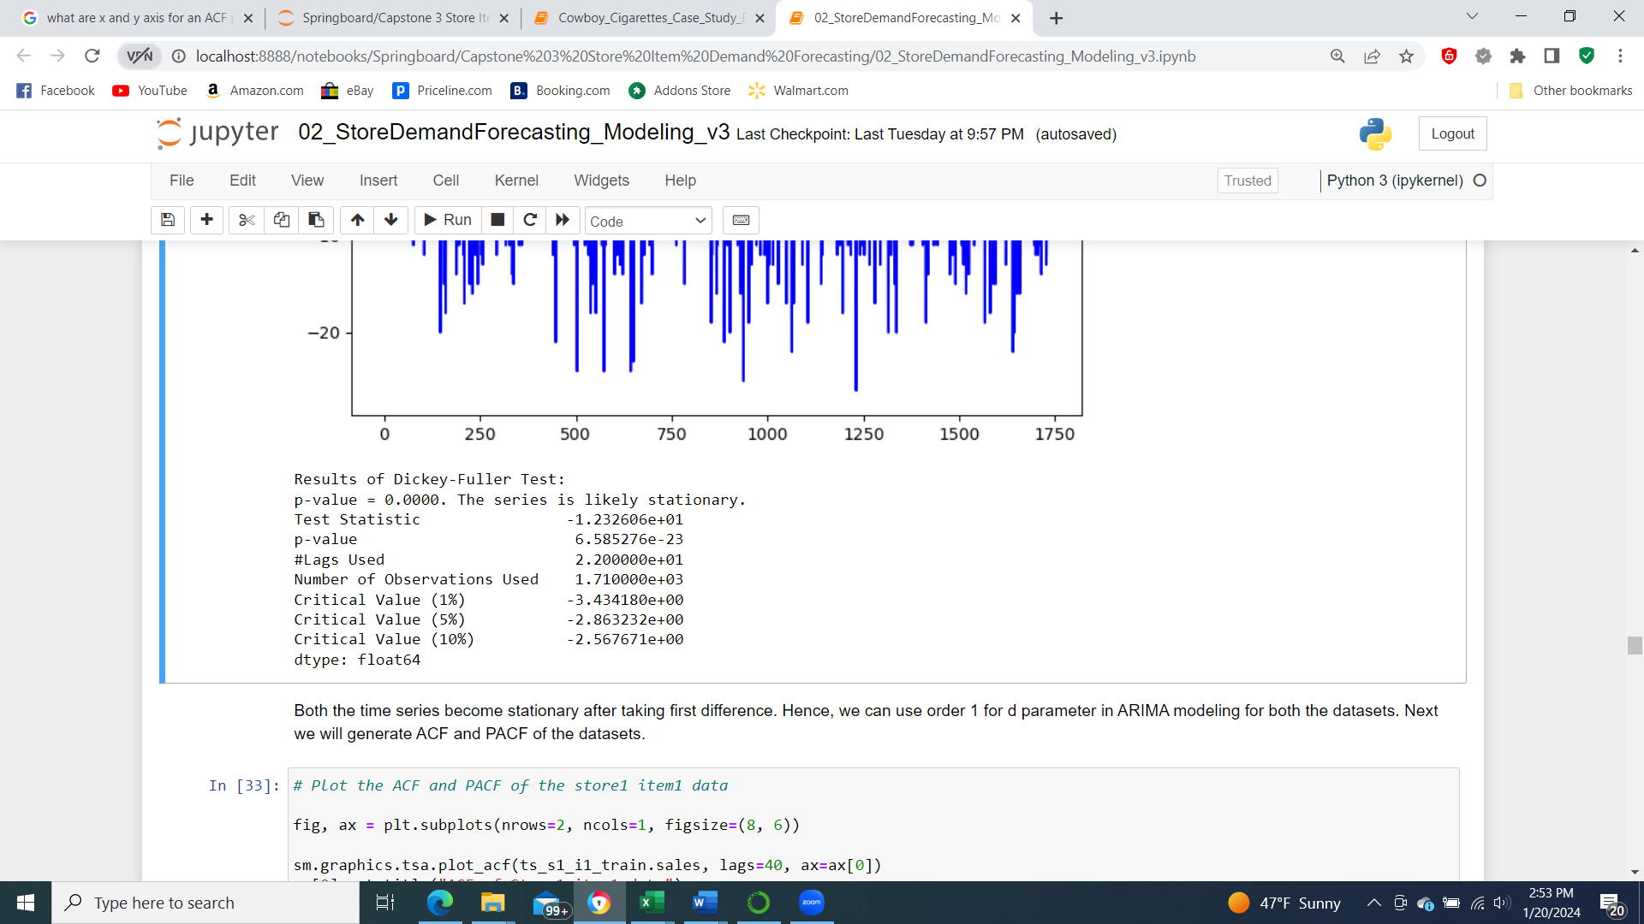

Figure 10: Test for stationarity for the time series data after first difference.

The results from the Dickey-Fuller test for first difference data shows that we can reject the null hypothesis that the data is not stationary. From this test we can use d=1 for the ARIMA model. Next, the parameters p and d will be estimated from ACF and PACF plots.

**ACF and PACF and estimate p,q:**

The auto-correlation and partial auto-correlation plots are generated for the training data after first difference for max lags of 40. Figure 11 shows the two plots. Based on the plots the ACF is small after lag 1 and PACF has small values after lag 6. We can use p and q values of 6 and 1 for ARIMA modeling.

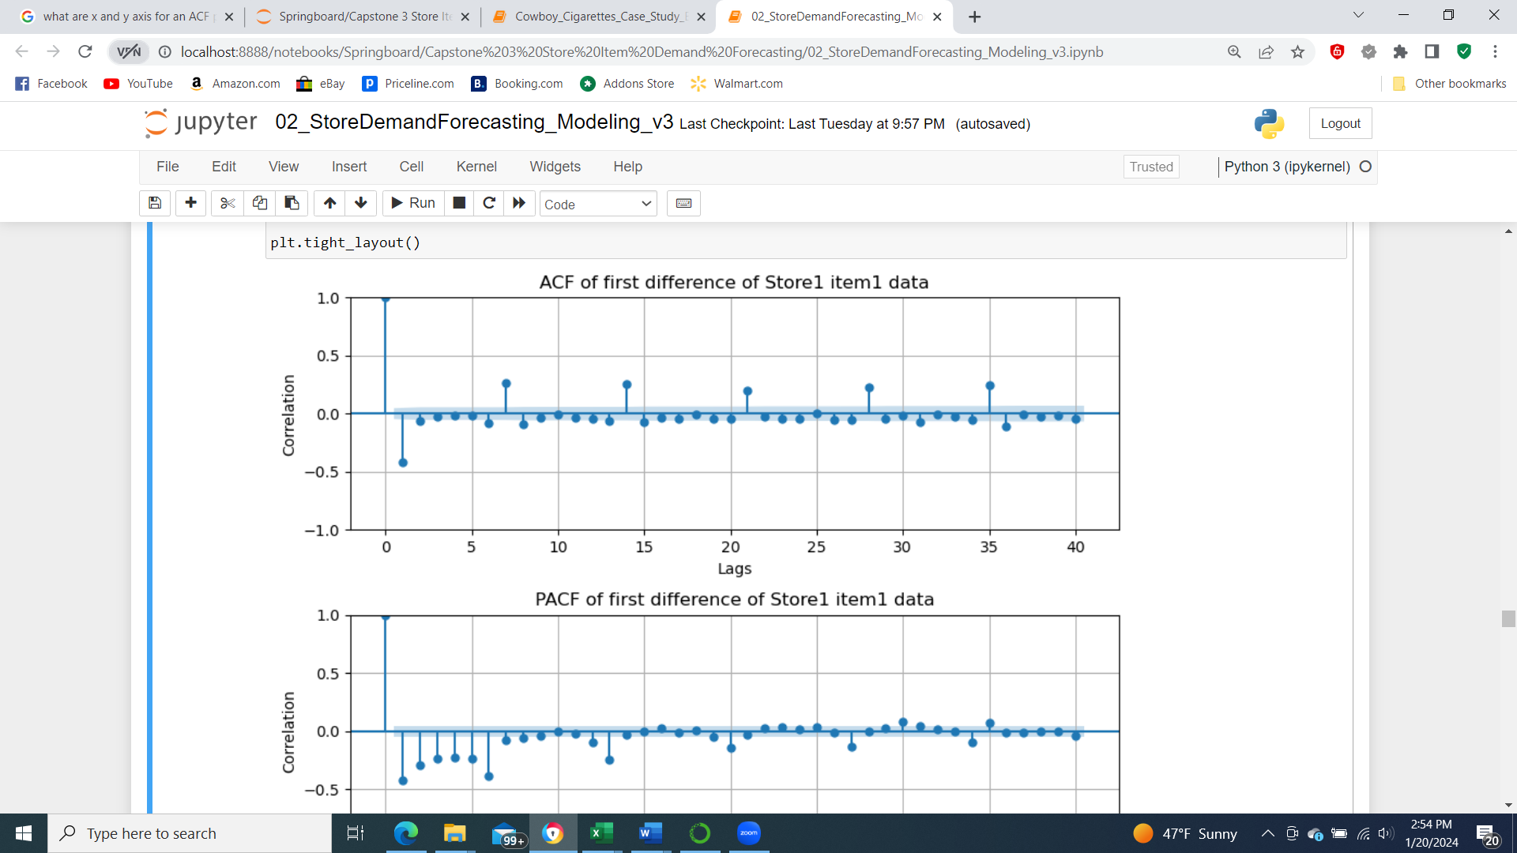

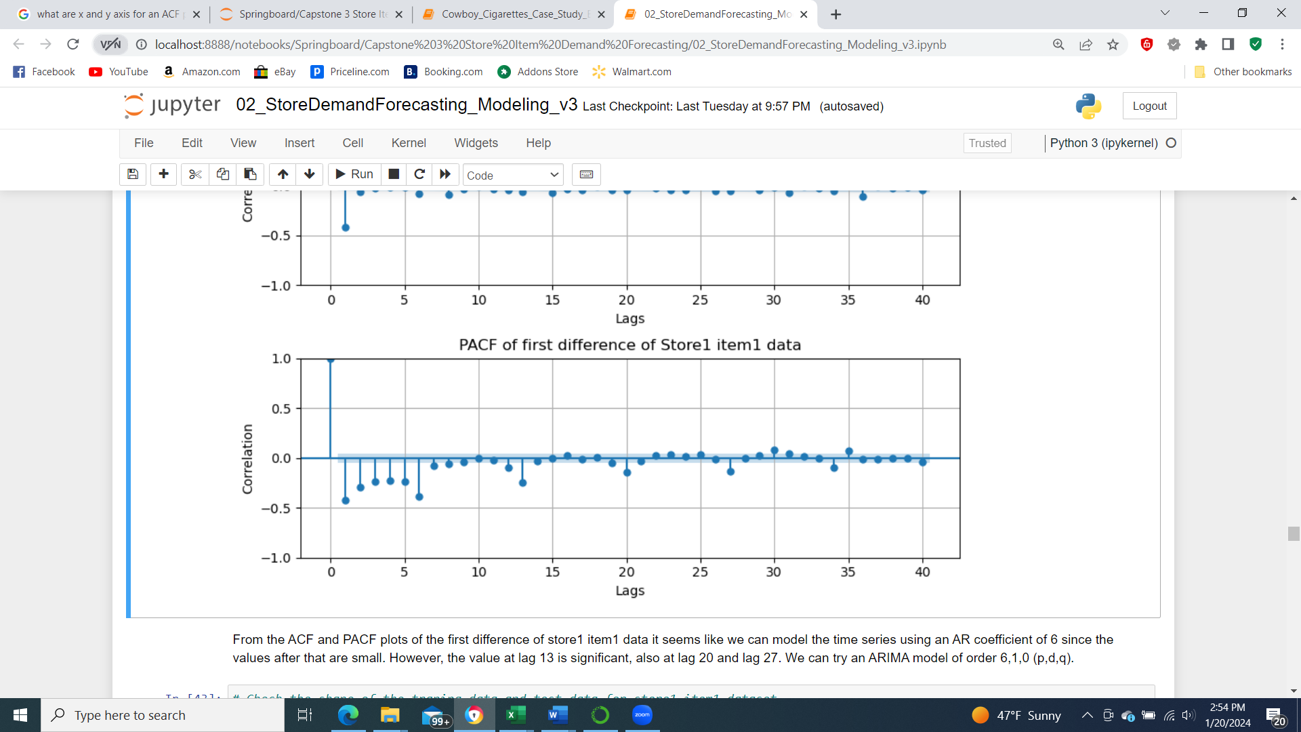

Figure 11: ACF and PACF of the first difference time series data.

Modeling Results:

**ARIMA (6,1,0):**

The training data is modeled using an ARIMA model of order 6,1,0. Below is a summary of model parameters, coefficients, AIC, BIC etc.

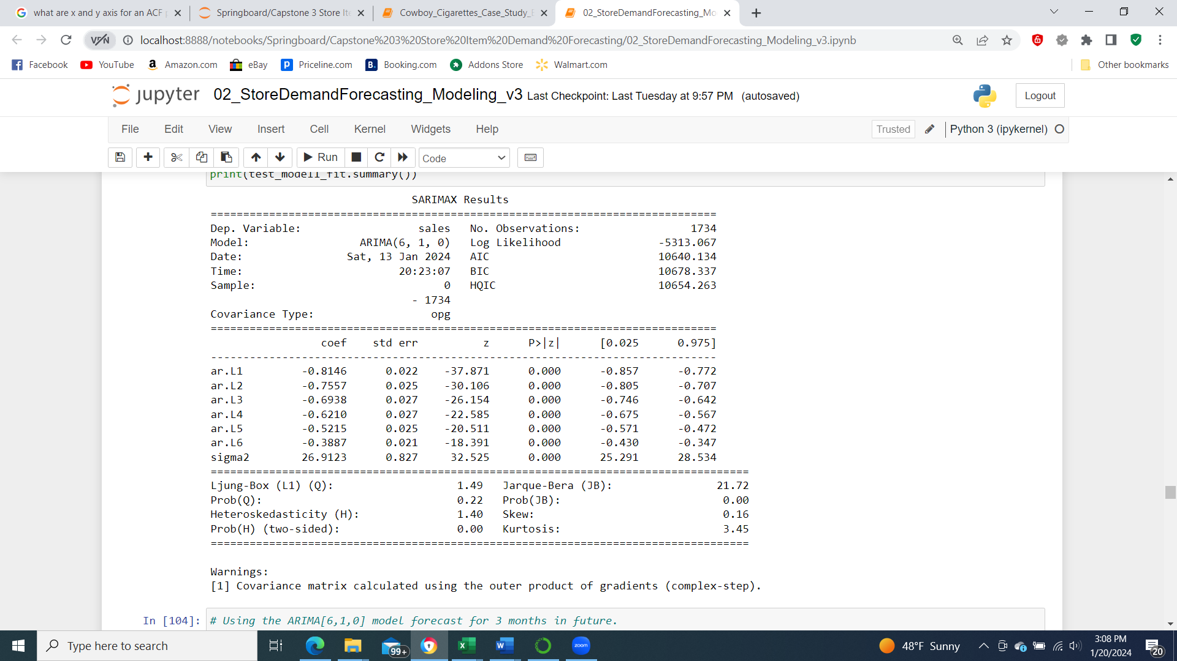

Figure 12: Summary of ARIMA model.

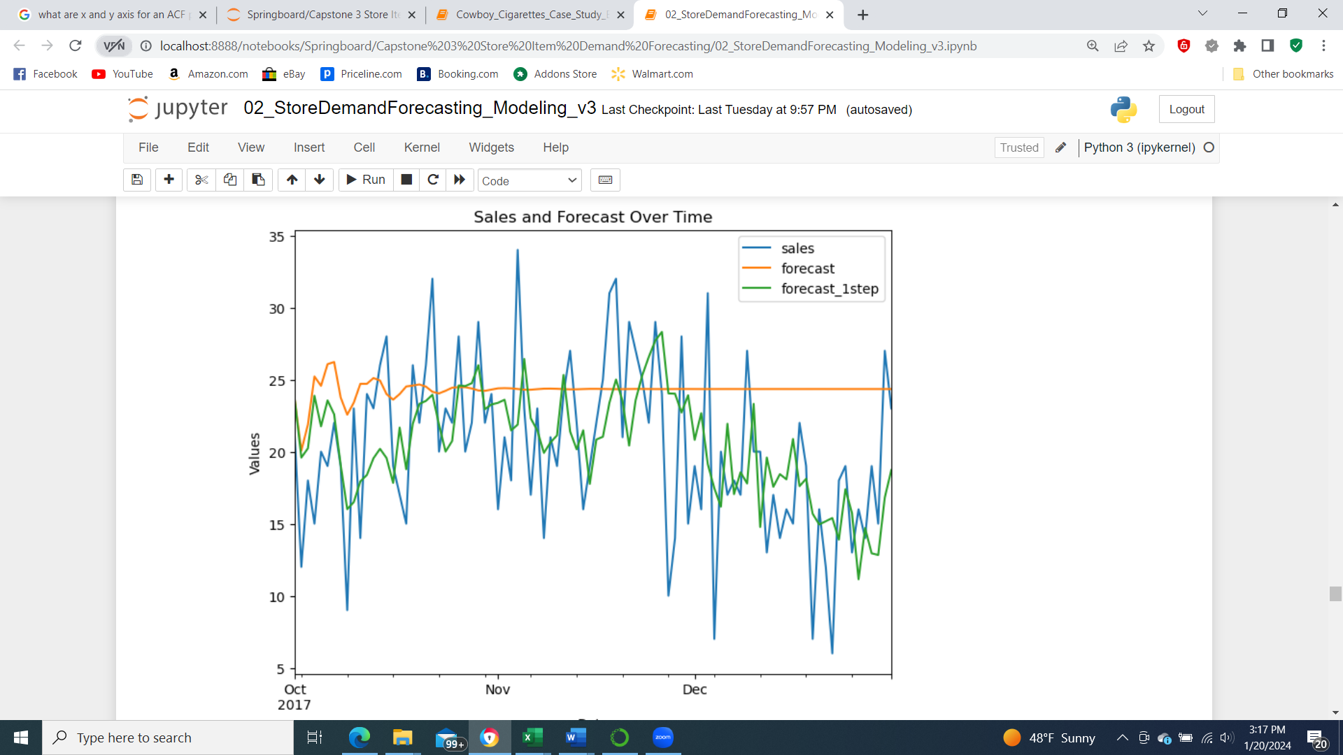

Predict for 3 months Predict 1 step

MAE: 5.79 4.37

MAPE: 39.63% 26.24%

SMAPE: 28.57% 22.88%

Figure 13: Forecast results using ARIMA (6,1,0) model.

The model was used to forecast the sales for last three months. The forecasting was done in two ways. First, all the future values were forecasted in one go. In the second method only for 1 day in future the forecast was predicted and true value from test data was appended to the training and iterated until the last sample. An error function was defined that calculates the error in prediction. The function returns three types of error: MAE (mean absolute error), MAPE (mean absolute percentage error) and SMAPE (symmetric mean absolute percentage error).

Based on the two modeling results shown in Figure 13 above here are the observations:

* From the plot we can see that ARIMA [6,1,0] model did not quite accurately model the predictions for store1 item1.
* For the first week the prediction seemed to be close to true values but after one month the prediction was constant.
* The prediction curve tapered after a few samples.
  + The MAPE error is ~40% and SMAPE is ~29% which seems a little high.
* When the modeling was used to predict only one sample at a time then the results improved.
  + Overall seasonal trend can be seen on the predictions which is encouraging.
  + The MAPE error is ~26% and SMAPE error is ~23% which is a big improvement from the previous model.

Ideally, we would like to predict for all the future values (3 months) using the training data only. Considering the results, it is possible that there is some seasonal component that ARIMA is not able to model and/or the order of the ARIMA model was not accurate. We will explore the second possibility in the next section. For different p,d,q values different ARIMA models will be generated and AIC-BIC will be used to select the best model. Errors from prediction will be explored for all models.

**ARIMA model iterating over various p,d,q values:**

For all combinations of values of p from 1 to 10, d from 1 to 3 and q from 1 to 10, an ARIMA model of order p,d,q is modeled and fit to training data. The model is used to forecast the values for the test data. Error is calculated for each iteration. The data is documented in a data-frame and the models with lowest AIC, BIC, MAE, MAPE and SMAPE are filtered.

Below is a list of models with lowest overall values.

Order with minimum AIC: (4, 2, 2)

Order with minimum BIC: (4, 2, 2)

Order with minimum MAE: (3, 3, 9)

Order with minimum MAPE: (8, 3, 9)

Order with minimum SMAPE: (3, 3, 9)

As we know that first difference of 1 was enough for the stationarity test. So, for d=1 the models with lowest AIC, BIC and error are shown below:

Order with minimum AIC (when d=1): (7, 1, 9)

Order with minimum BIC (when d=1): (7, 1, 9)

Order with minimum MAE (when d=1): (9, 1, 10)

Order with minimum MAPE (when d=1): (9, 1, 10)

Order with minimum SMAPE (when d=1): (9, 1, 10)

Considering the information from these tests, ARIMA models with order 3,3,9 and 9,1,10 will be tested to see if the forecasting results are better than 6,1,0. Figure 14 and Figure 15 show the results from forecasting using the two models. From the figures it seems like even the error is small the prediction is not great. Likely the model is overfitting and our parameters estimated earlier 6,1,0 are probably better.

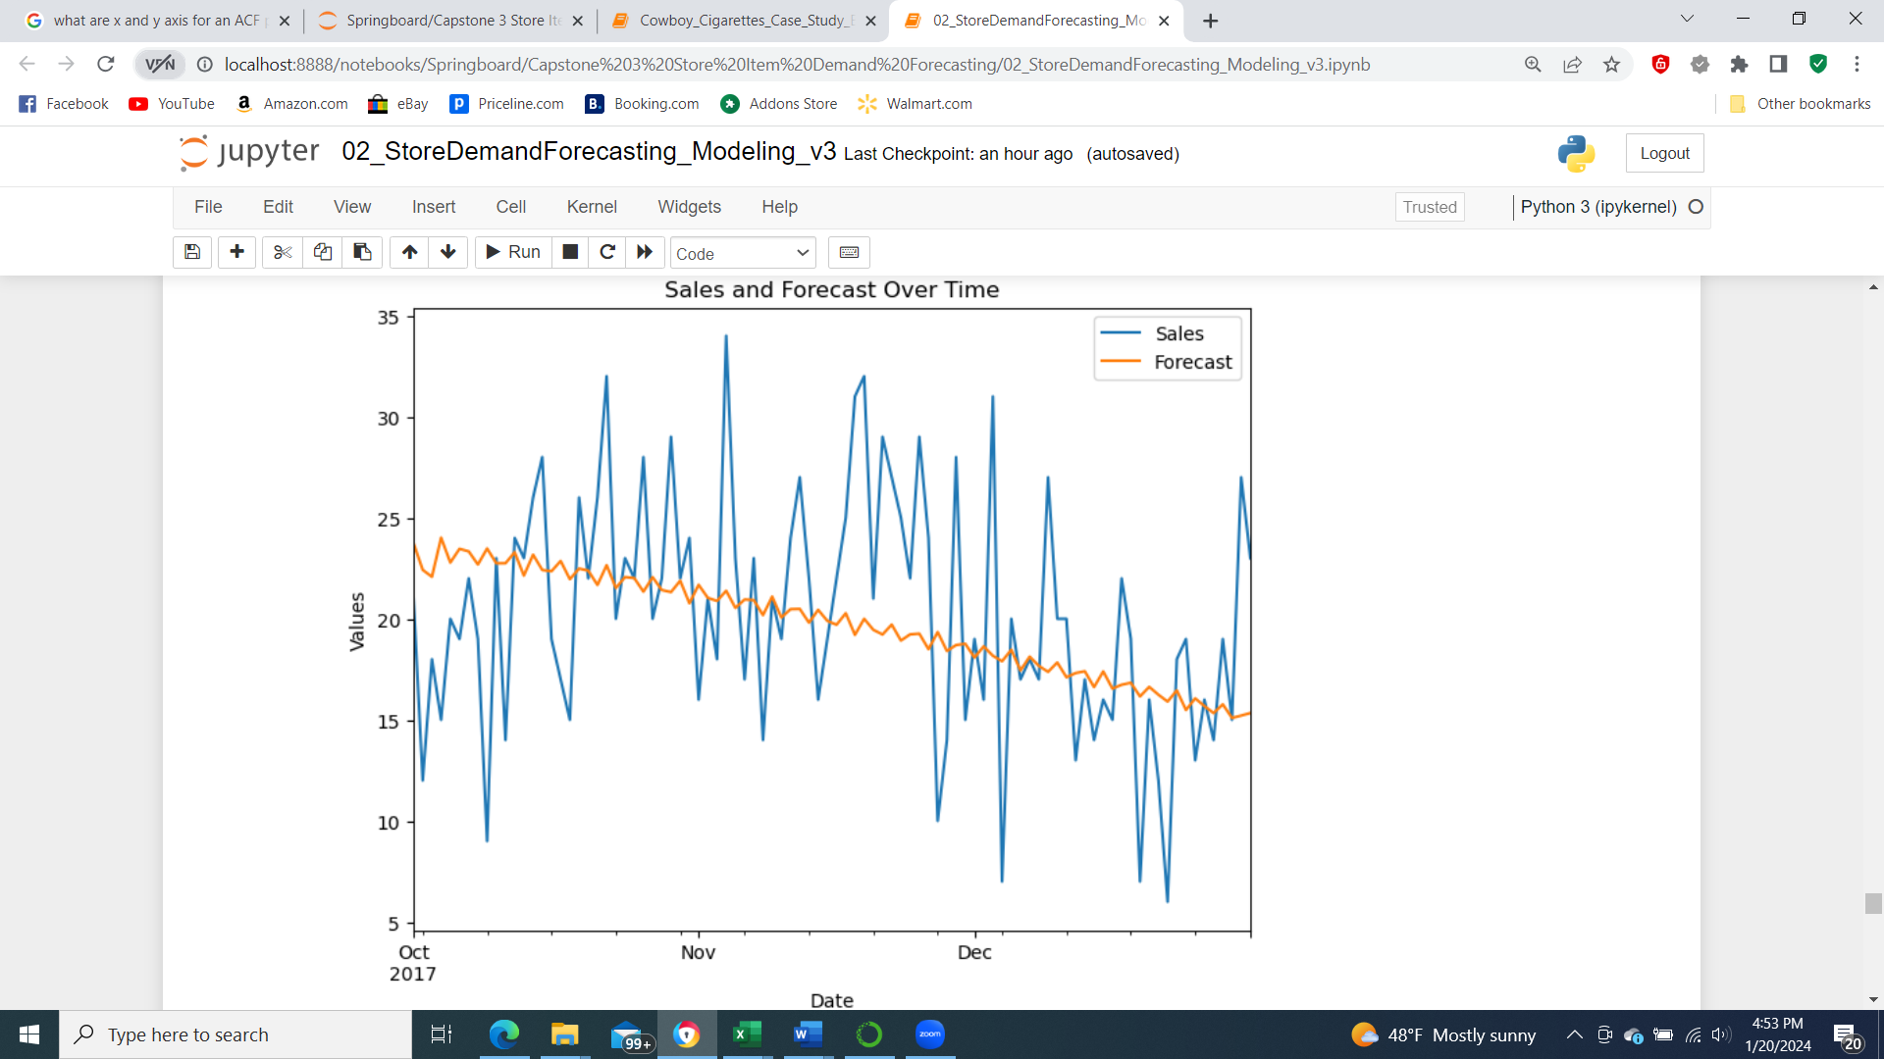

Figure 14: Forecast results using ARIMA (3,3,9) model.

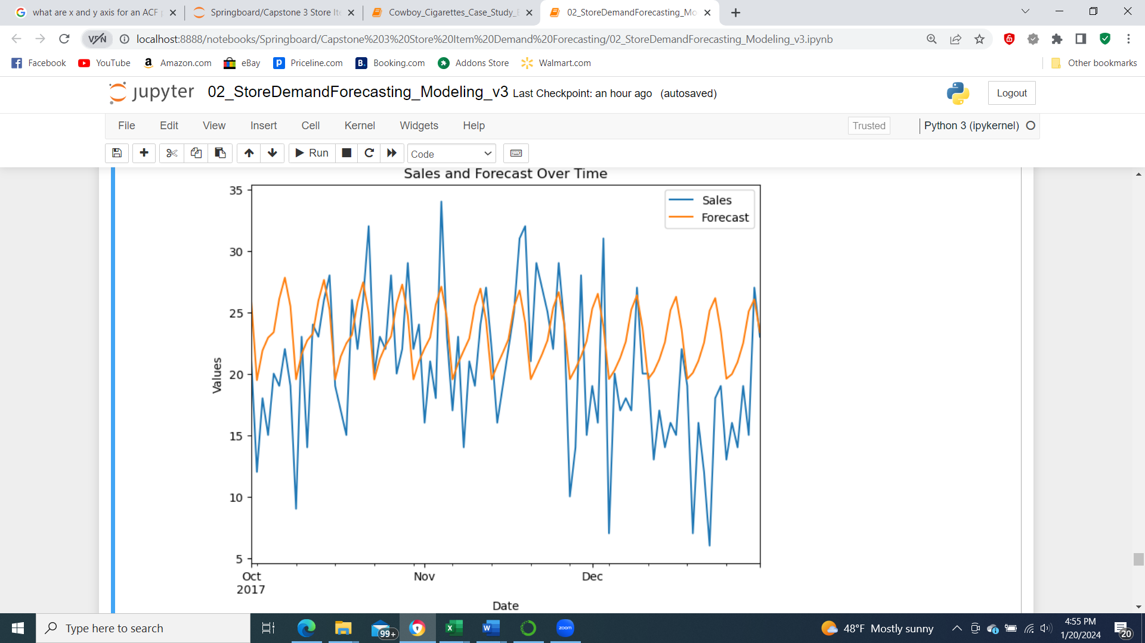

Figure 15: Forecast results using ARIMA (9,1,10) model.

Since changing the model order did not improve the prediction any further, next seasonality will be tested using SARIMA model.

**SARIMA (6,1,0) with a seasonal component of 7 days and exogenous variables:**

From the time series plots, PACF etc. we know there is a weekly seasonal component. Here SARIMA was tried with same p,d,q (6,1,0) and with a seasonal value of 7. The forecasting results are shown in Figure 16. Additionally, the other time related features extracted earlier month, year, day of the year, day of the week were used as the exogenous component to the model. The model was used for forecasting and the results are shown in Figure 17 as well. The errors from forecasting for both the models are shown as well.

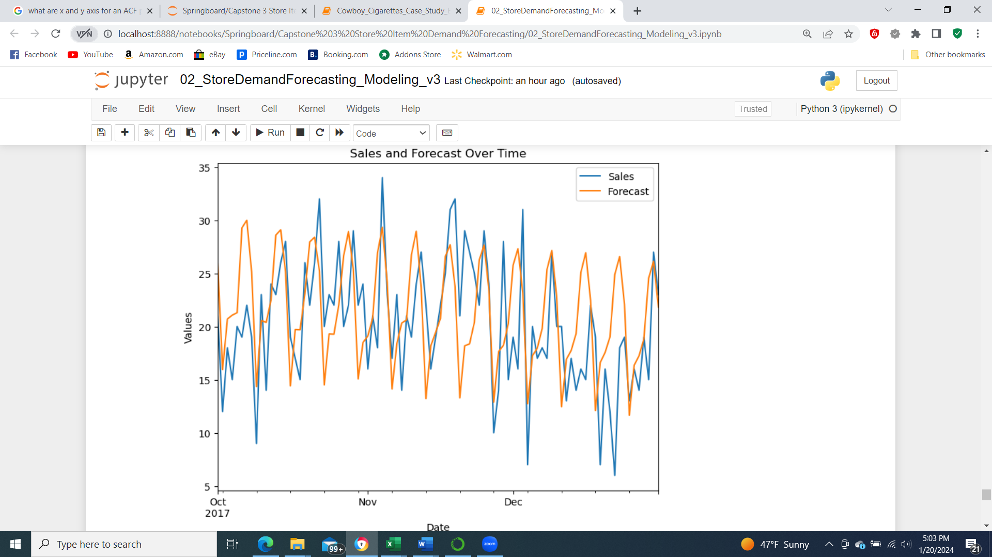

MAE: 4.8

MAPE: 29.02%

SMAPE: 24.49%

Figure 16: Forecast results using SARIMA (6,1,0,7) model.

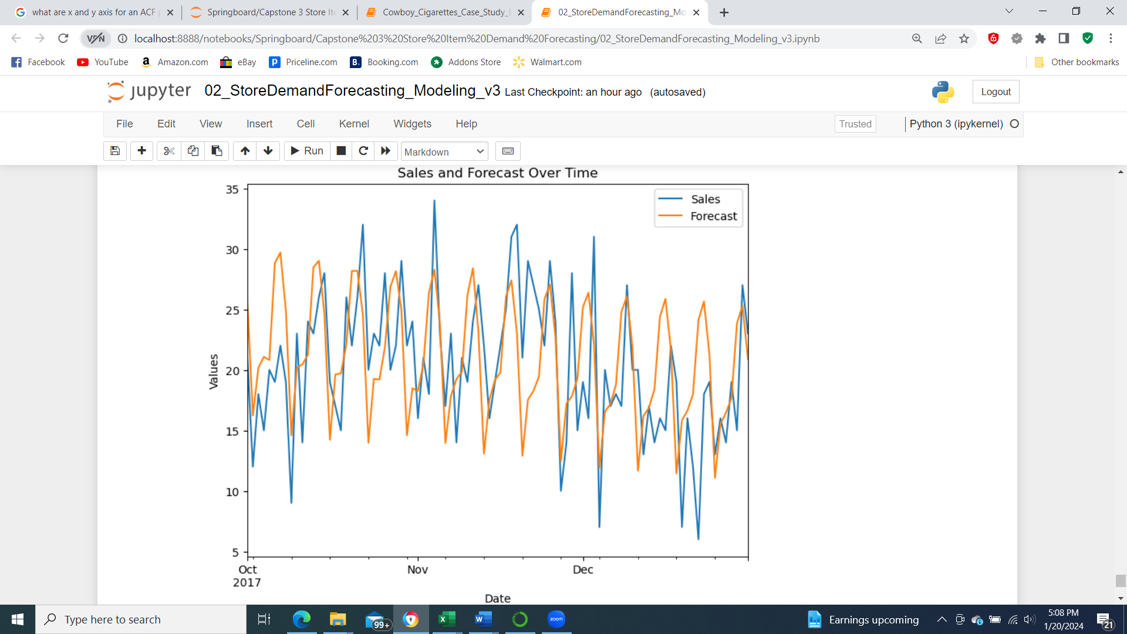

MAE: 4.73

MAPE: 28.34%

SMAPE: 24.44%

Figure 17: Forecast results using SARIMA (6,1,0,7) model with exogenous features.

Overall, SARIMA model forecasting results were better than ARIMA. The forecasting improved a little by adding the exogenous variables. The MAPE error is lowered from 40% to 28%. SMAPE error is also less from 29% to 24%. For this data SARIMA with exogenous variables gave the best results. In order to predict for another store item combination we can repeat the steps of predicting model order and retrain and forecast.